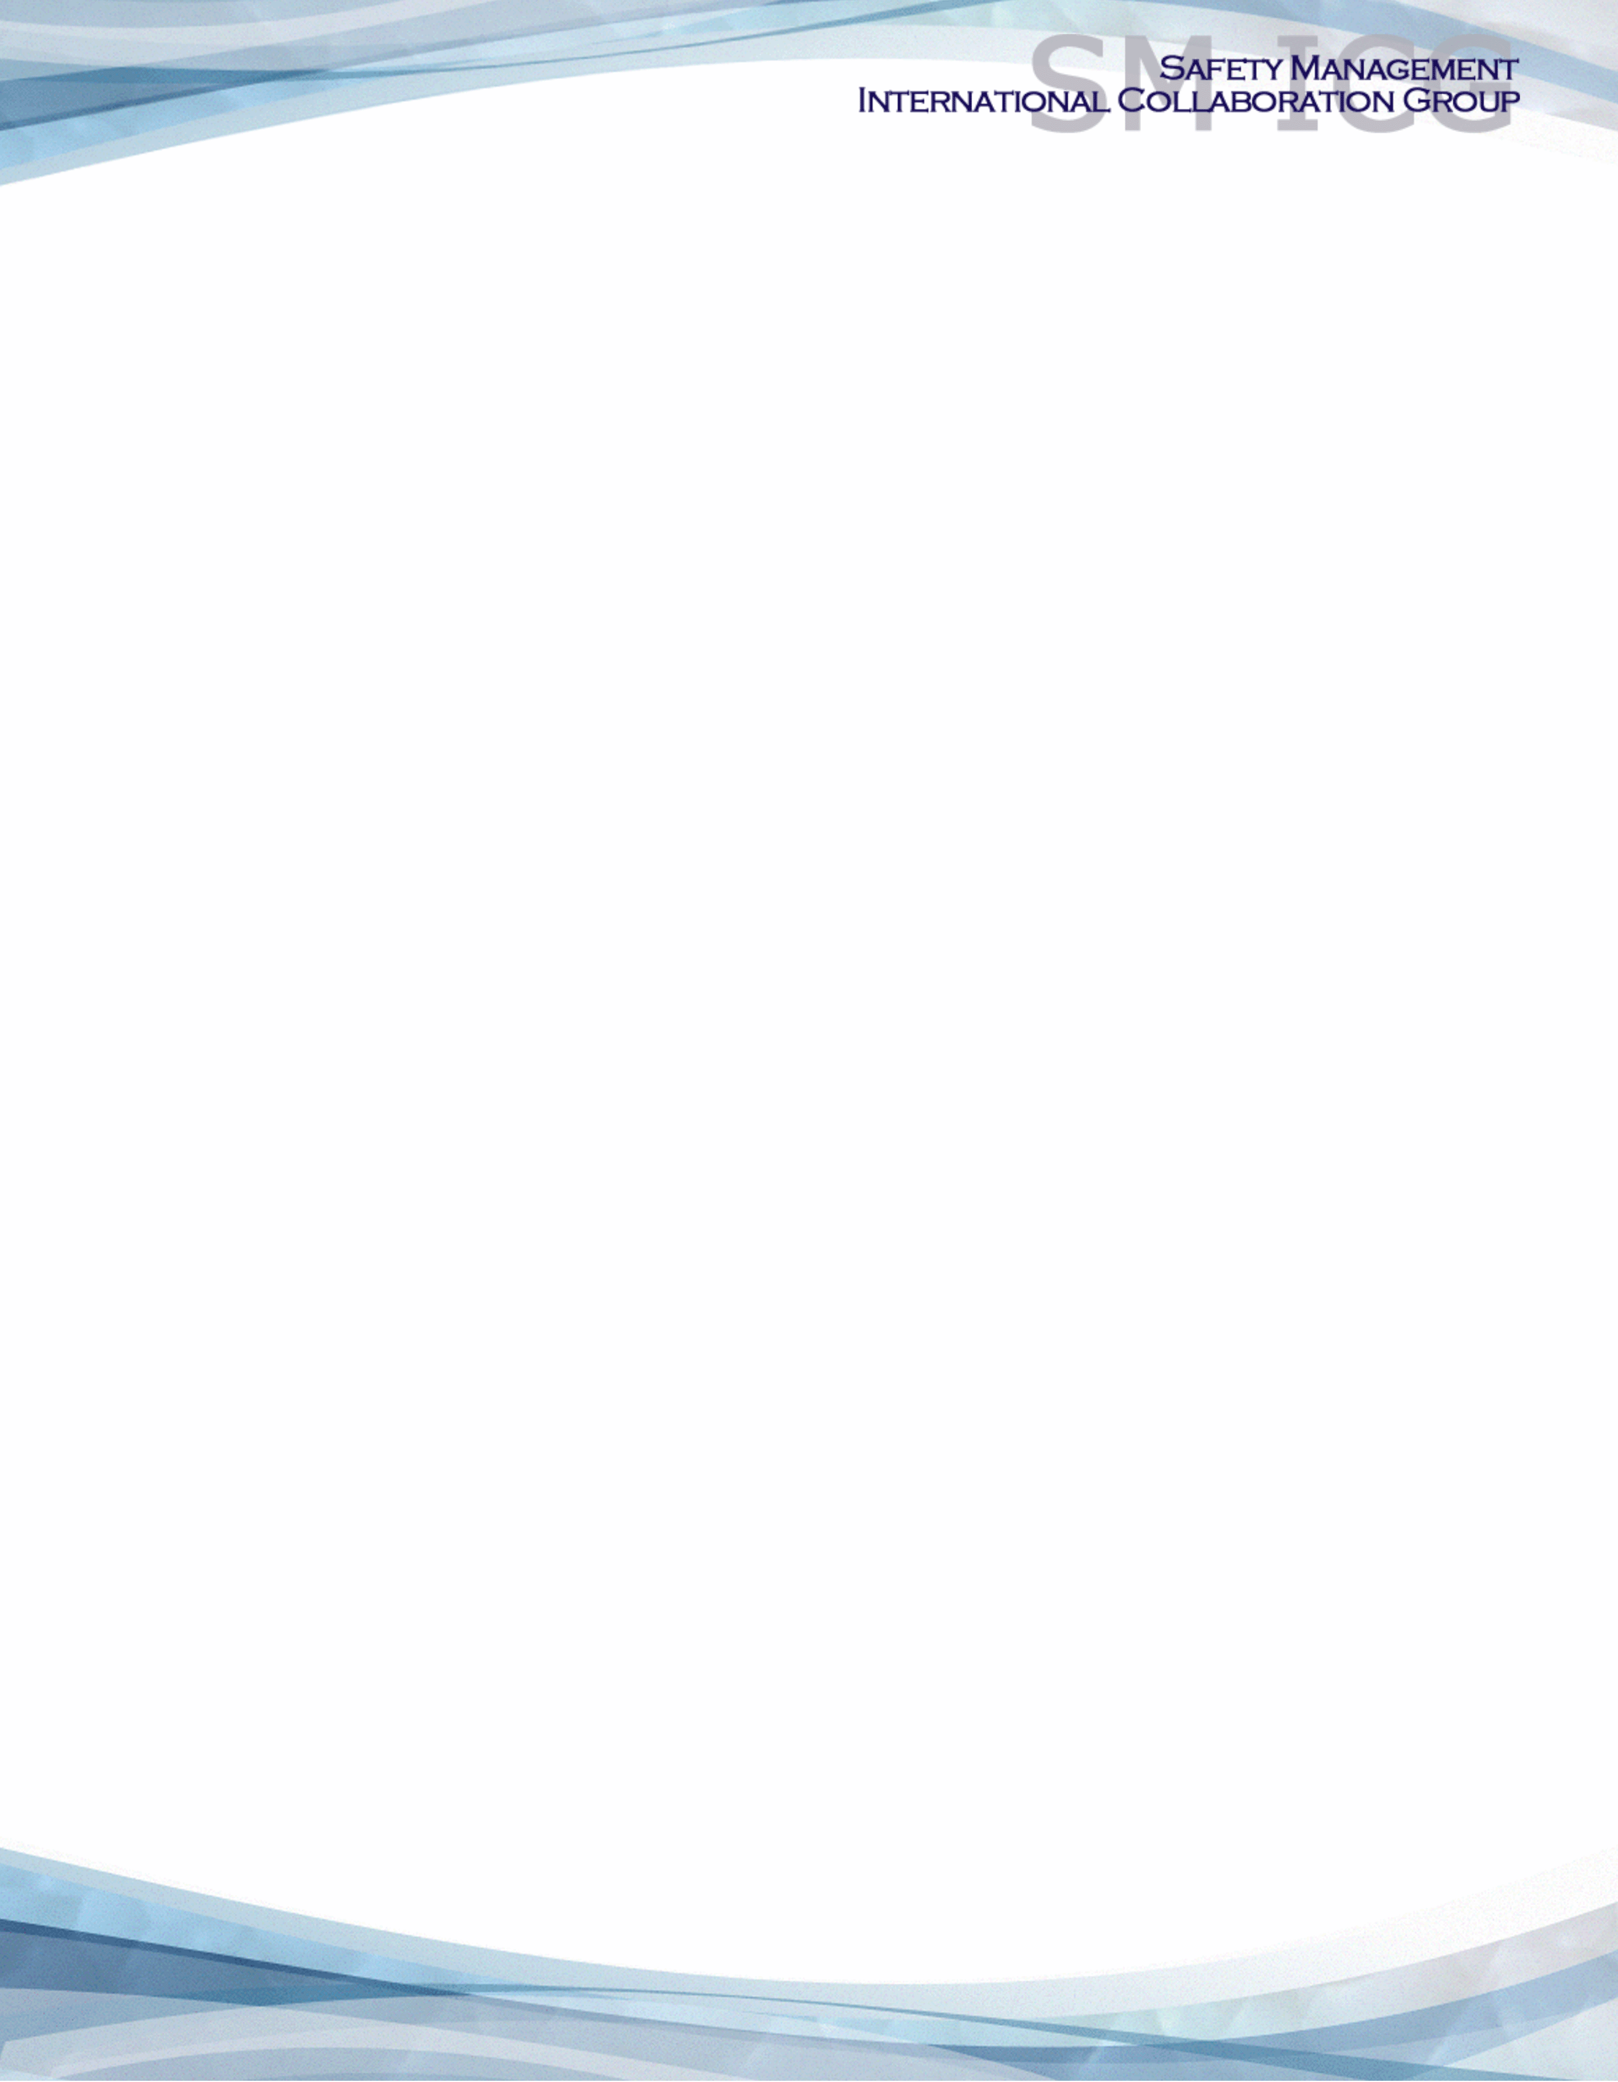**Introduction**

The International Civil Aviation Organization (ICAO) requires SMS for the management of safety risk in air operations, maintenance, air traffic services and aerodromes. These requirements have been expanded to include flight training and design and production of aircraft. Furthermore, ICAO has published safety management requirements for States by mandating that States establish a State Safety Programme (SSP) in order to achieve an acceptable safety performance in their civil aviation systems. As such, it is beneficial for authorities to harmonize their Safety Management System (SMS) and SSP requirements and implementation activities and collaborate on common topics of interest.

In this document, the term “organization” refers to an aviation service provider, operator, business, and company, as well as aviation industry organizations; and the term “authority” refers to the regulator authority, Civil Aviation Authority (CAA), National Aviation Authority (NAA), and any other relevant government agency or entity with oversight responsibility.

Authorities will benefit from collaboration and sharing of lessons learned and best practices. This collaboration will help authorities avoid duplication of efforts and enable them to better share information and provide oversight of multinational organizations. Aviation industry organizations will also greatly benefit from SMS requirement harmonization among authorities since many organizations own multiple certificate types in multiple nations. Additionally, sharing methods and tools will assist in developing robust and affordable safety management systems.

**Safety Management International Collaboration Group**

The European Aviation Safety Agency (EASA), the Federal Aviation Administration (FAA), ICAO, and Transport Canada Civil Aviation (TCCA) held a meeting in February 2009 to discuss the potential for SMS and SSP cooperation. Meeting participants agreed that there was indeed value to collaborating on SMS and SSP topics of interest and established the Safety Management International Collaboration Group (SM ICG). In 2009, the SM ICG agreed to meet semi-annually in addition to regular teleconferences and initiated three workgroups to begin developing products collaboratively.

The purpose of the SM ICG is to promote a common understanding of SMS/SSP principles and requirements, facilitating their application across the international aviation community. The SM ICG was established for collaboration and harmonization purposes and does not have authority over any of the participating organizations; each organization participates voluntarily. However, representatives make every effort to reach a common understanding when making SM ICG decisions/ recommendations or to provide dissenting opinions. Each representative is also expected to speak for his/her organization and share the organization’s position, rather than personal opinions.

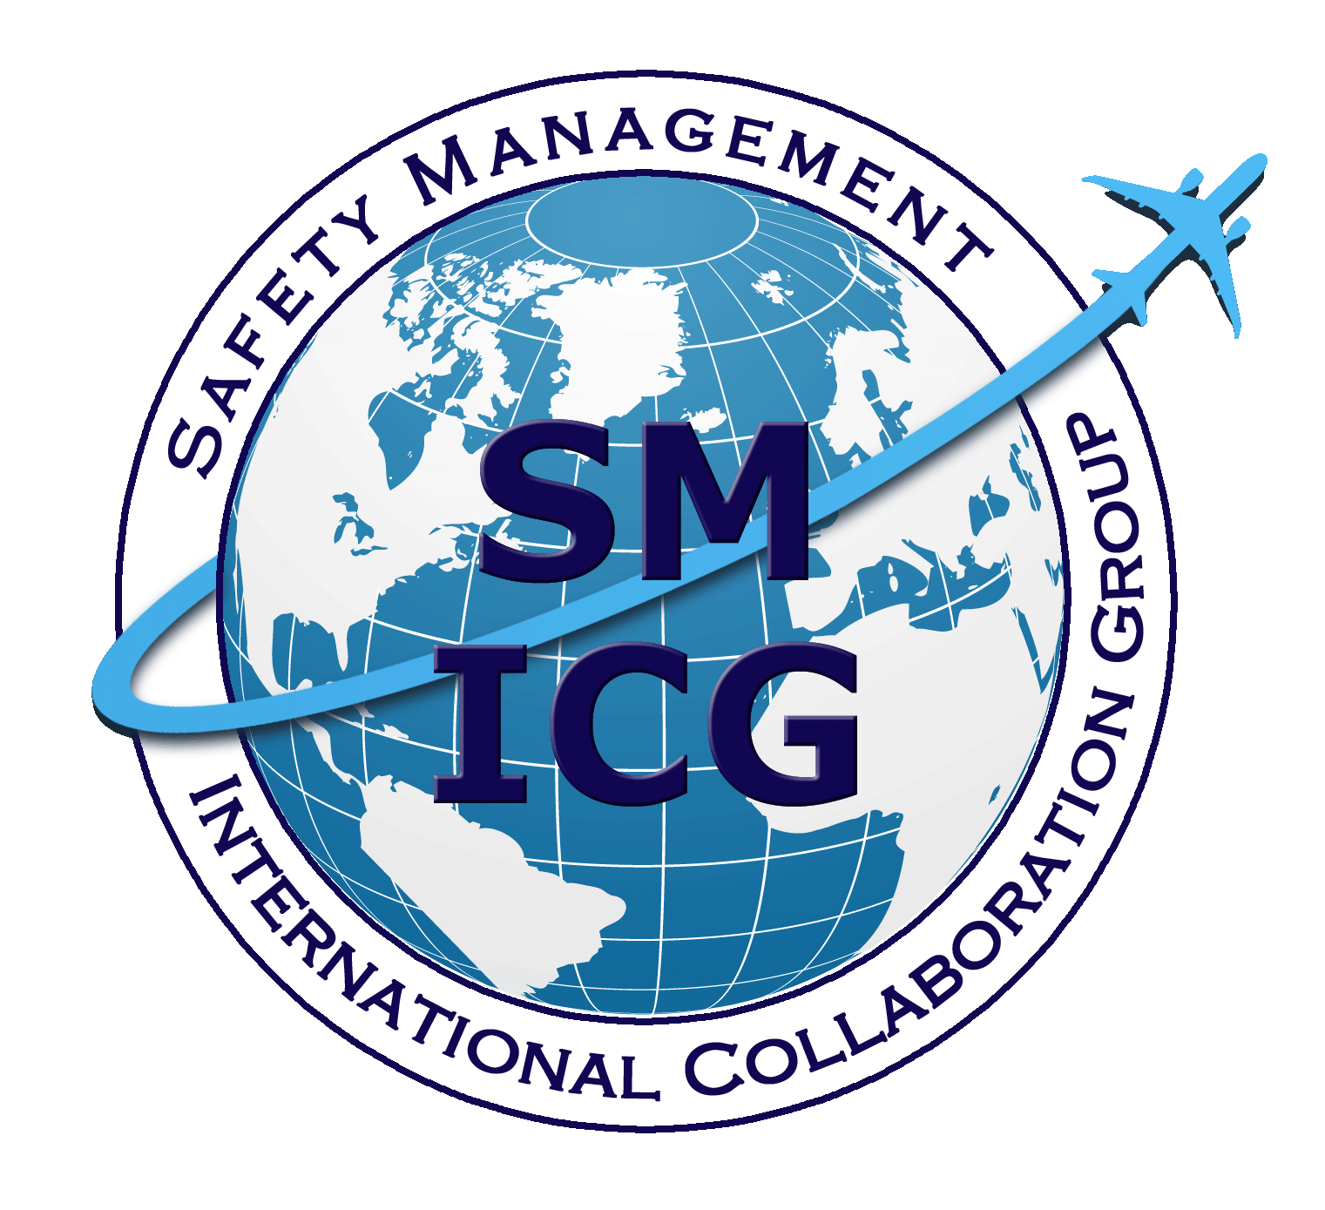The SM ICG interfaces with various stakeholders in the aviation system, including: industry members and groups; Commercial Aviation Safety Team (CAST), European Commercial Aviation Safety Team (ECAST), other comparable organizations; authorities that have implemented or are implementing SMS and SSP; and ICAO and safety management development groups, such as the ICAO Safety Management Panel (SMP).

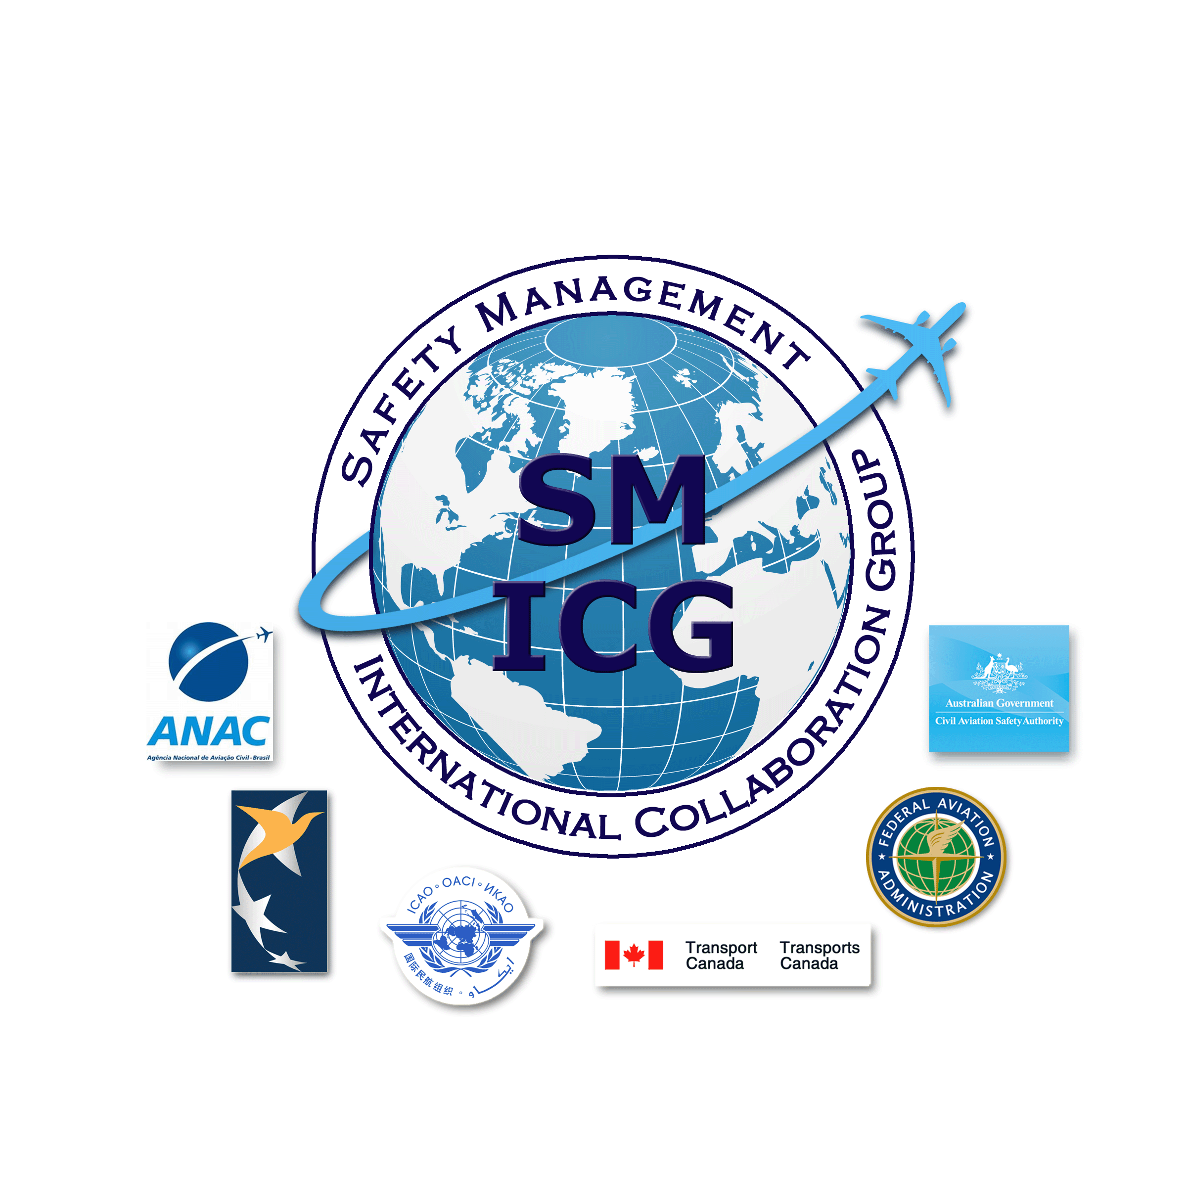

The current core membership of the SM ICG includes the Aviation Safety and Security Agency (AESA) of Spain, the National Civil Aviation Agency (ANAC) of Brazil, the Civil Aviation Authority of the Netherlands (CAA NL), the Civil Aviation Authority of New Zealand (CAA NZ), the Civil Aviation Authority of Singapore (CAAS), Civil Aviation Department of Hong Kong (CAD HK), the Civil Aviation Safety Authority (CASA) of Australia, the Direction Générale de l'Aviation Civile (DGAC) in France, the Ente Nazionale per l'Aviazione Civile (ENAC) in Italy, the European Union Aviation Safety Agency (EASA), the Dominican Republic Civil Aviation Institute (IDAC), the Finnish Transport and Communications Agency (Traficom), the Irish Aviation Authority (IAA), Japan Civil Aviation Bureau (JCAB), the United States Federal Aviation Administration (FAA) Aviation Safety Organization, Transport Canada Civil Aviation (TCCA), United Arab Emirates General Civil Aviation Authority (UAE GCAA), and the Civil Aviation Authority of United Kingdom (UK CAA). Additionally, the International Civil Aviation Organization (ICAO) is an observer to this group.

Members of the SM ICG:

* Collaborate on common SMS/SSP topics of interest
* Share lessons learned
* Encourage the progression of a harmonized SMS/SSP
* Share products with the aviation community
* Collaborate with international organizations such as ICAO and civil aviation authorities that have implemented or are implementing SMS and SSP

For further information regarding the SM ICG please contact:

Bernard Bourdon Sarah Matresky Eugene Huang  
EASA TCCA FAA, Aviation Safety  
+49 221 89990 2022 +1 343-571-8742 (202) 267-7577  
[bernard.bourdon@easa.europa.eu](mailto:bernard.bourdon@easa.europa.eu) [sarah.matresky@tc.gc.ca](mailto:sarah.matresky@tc.gc.ca) [eugene.huang@faa.gov](mailto:eugene.huang@faa.gov)

Neverton Alves de Novais Charles Galea Aila Järveläinen  
ANAC CASA Traficom  
+55 61 3314 4606 +07 3144 7487 +359 29 534 6042  
[Neverton.Novais@anac.gov.br](mailto:Neverton.Novais@anac.gov.br) [Charles.Galea@casa.gov.au](mailto:Charles.Galea@casa.gov.au) [aila.jarvelainen@traficom.fi](mailto:aila.jarvelainen@traficom.fi)

Michael Pang  
CAAS  
+65 6422 7517  
[michael_pang@caas.gov.sg](mailto:michael_pang@caas.gov.sg)

SM ICG products can be found on SKYbrary at:<http://bit.ly/SMICG>