
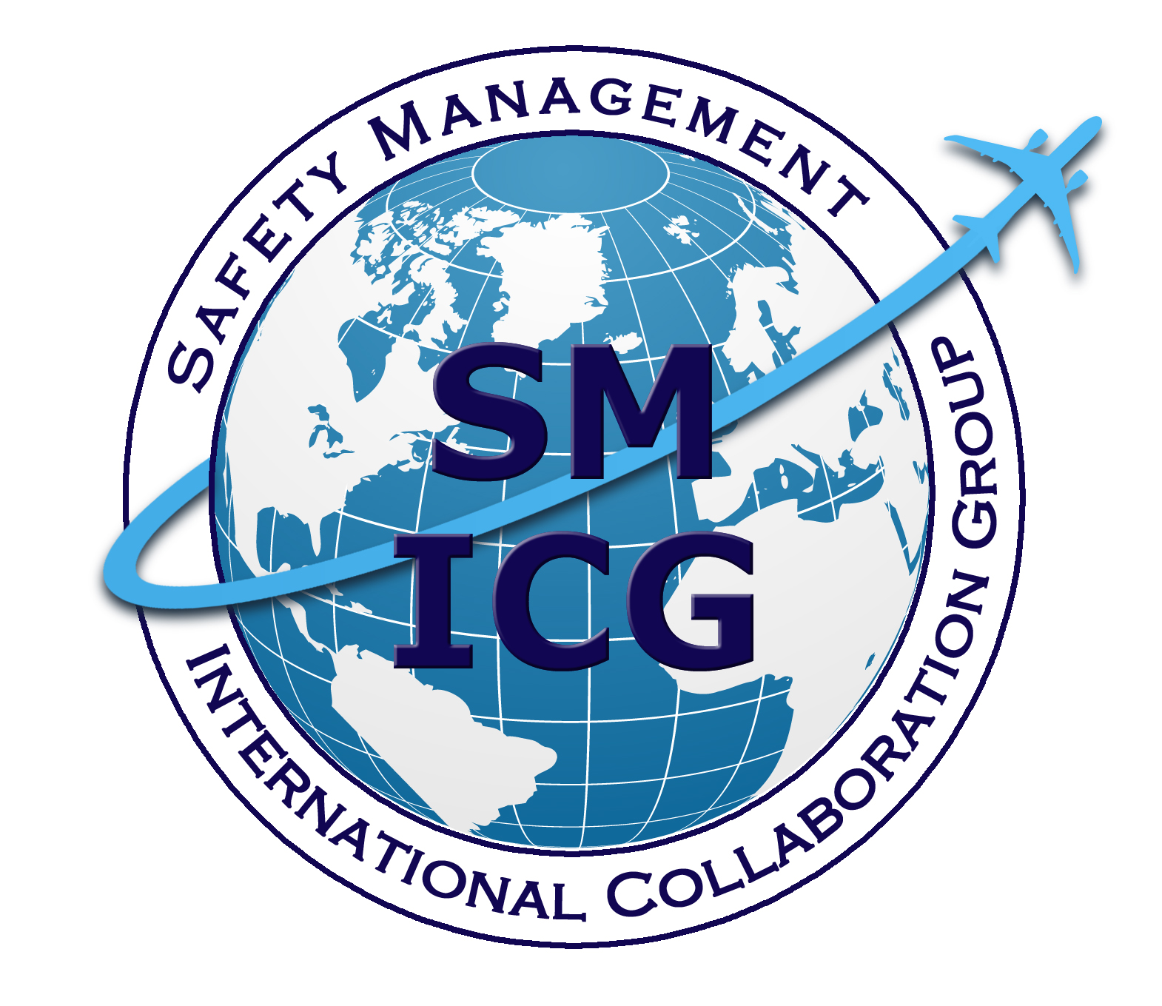
Organizational Culture Self-Assessment Tool and Guidance
for
Regulatory Authorities
March 2019
This paper was prepared by the Safety Management International Collaboration Group (SM ICG). The purpose of the SM ICG is to promote a common understanding of Safety Management System (SMS)/State Safety Program (SSP) principles and requirements, facilitating their application across the international aviation community. In this document, the term organization refers to a product or service provider, operator, business, and company, as well as aviation industry organizations; while the term authority refers to the regulator authority, Civil Aviation Authority (CAA), National Aviation Authority (NAA), and any other relevant government agency or entity with oversight responsibility.

The current core membership of the SM ICG includes the Aviation Safety and Security Agency (AESA) of Spain, the National Civil Aviation Agency (ANAC) of Brazil, the Civil Aviation Authority of the Netherlands (CAA NL), the Civil Aviation Authority of New Zealand (CAA NZ), the Civil Aviation Authority of Singapore (CAAS), Civil Aviation Department of Hong Kong (CAD HK), the Civil Aviation Safety Authority (CASA) of Australia, the Direction Générale de l'Aviation Civile (DGAC) in France, the Ente Nazionale per l'Aviazione Civile (ENAC) in Italy, the European Aviation Safety Agency (EASA), the Federal Office of Civil Aviation (FOCA) of Switzerland, the Finnish Transport Safety Agency (Trafi), the Irish Aviation Authority (IAA), Japan Civil Aviation Bureau (JCAB), the United States Federal Aviation Administration (FAA) Aviation Safety Organization, Transport Canada Civil Aviation (TCCA), United Arab Emirates - General Civil Aviation Authority (UAE GCAA), and the Civil Aviation Authority of United Kingdom (UK CAA). Additionally, the International Civil Aviation Organization (ICAO) is an observer to this group.

Members of the SM ICG:
- Collaborate on common SMS/SSP topics of interest
- Share lessons learned
- Encourage the progression of a harmonized SMS/SSP
- Share products with the aviation community
- Collaborate with international organizations, such as ICAO and civil aviation authorities, that have implemented or are implementing SMS and SSP.

For further information regarding the SM ICG please contact:
Claudio Trevisan Sean Borg Eugene Huang
EASA TCCA FAA, Aviation Safety
+49 221 89990 6019 (613) 990-5448 (202) 267-7577
claudio.trevisan@easa.europa.eu sean.borg@tc.gc.ca eugene.huang@faa.gov

Neverton Alves de Novais Ash McAlpine
ANAC CASA
+55 61 3314 4606 + 07 3144 7411
Neverton.Novais@anac.gov.br Ashley.Mcalpine@casa.gov.au

SM ICG products can be found on SKYbrary at: http://bit.ly/SMICG

SM ICG products can be found on SKYbrary at: http://bit.ly/SMICG

To obtain an editable version of this document, contact smicg.share@gmail.com.
Assessment of Organizational Cultures for Regulatory Authorities

Abstract/Executive Summary
At the same time aviation safety continues to advance beyond technical and human factors as the dominant issues in the cause of aviation accident, more emphasis is being placed on organizational management and systemic factors. This is not to say that technical and human factors are no longer important, but rather there is a realization that aviation operates in increasingly complex systemic contexts. Thus, it is important to address how these factors are managed. Both service provider organizations and regulators play essential roles in overall safety of flight, but, while these roles are highly interdependent, they differ in how they impact safety.
Service providers must balance mission, money, and safety in ways that provide efficient, cost-effective, safe services. They must recognize and observe appropriate boundaries in all these domains to remain viable. Regulators must remain aware of the status of operational safety in the organizations that they oversee, while exercising reasonable and effective controls through a variety of means.
In both cases, the cultures of these entities set the tone for their behaviors and performance. One of the most important objectives for regulators is to foster the growth of safety cultures and, therefore, the management capabilities of the service providers that they oversee.
The process should, therefore, begin with a careful understanding of a service provider’s culture in terms of their approach to safety management. The SMICG has published a promotional pamphlet that addresses safety culture for service providers. The SMICG has also published a tool and a methodology to assess the cultures of service provider organizations. These tools can assist regulators in gaining a better understanding of the maturity and safety management capabilities of the organizations of the service providers that they oversee.
This document will explore the assessment of regulators’ organizational cultures and their influence on the service provider organizations that they oversee. Appendix 1 provides an initial screening survey that can be used not only to introduce the concepts of organizational culture to regulator personnel, but also to highlight some areas for additional study and assessment.
Assessment of Organizational Cultures for Regulatory Authorities

Introduction

One of the most important objectives for regulators is to foster the growth of safety cultures and, therefore, the management capabilities of the service providers that they oversee. The process should, therefore, begin with a careful understanding of a service provider’s culture in terms of their approach to safety management. The SMICG has published a promotional pamphlet that addresses safety culture for service providers.

Regulators perform a fundamentally different role to that of service providers. Regulatory authorities do not provide direct products or services to consumers in the public, but rather they conduct oversight processes to provide assurance to the users that service providers’ products and services meet their safety responsibilities. The key contribution regulators offer to safety stems from their influence on service provider performance. They accomplish this by identifying major hazards in the aerospace system, establishing controls, and performing safety oversight. Regulators also work collaboratively with service providers on voluntary efforts, providing guidance in ways that foster growth in their safety cultures and safety management capabilities.

Assessment of regulator culture should, therefore, address not only how they make decisions and manage actions within their organizations, but also how they adapt their approach to relationships with service providers.

Understanding a Service Provider Organization: Maintaining Balance. Service providers’ roles in safety and quality performance have frequently been described in terms of balancing production (performing their mission as a product or service provider) and protection (conducting safe operations or providing safe products). However, a third element also comes into play: that of allocating resources and maintaining a balance between mission (production), money (resources), and safety (protection). Mangers of these organizations must maintain a delicate balance between these elements in order to provide efficient, cost-effective services and positive return on investment, all the while maintaining acceptable margins of safety. Elements of a service provider’s organizational culture can be the key indicators of how such an organization sets priorities, identifies hazards, allocates resources, and manages safety risks.

Cultural Fundamentals
The concept of culture is always associated with the collective knowledge, beliefs, and behaviors of members of a group. Organizational culture refers to the way that those aspects are applied to a given organization. Certain characteristics are common to all types of organizations; others are common to certain types of organizations, while others characterize specific organizations.
Safety Culture is a term that is frequently used to describe those aspects of a service provider’s organizational culture that apply to how they manage safety in the balance of decision-making. Safety cultures are not created or established. All service provider organizations have a safety culture. What is important is how they manage their organizations to maintain effective control of risk in their operations.
Levels of Culture: Describing Maturity and Growth. Figure 1 is a safety culture model developed by the European Commercial Aviation Safety Team (ECAST) based on earlier material developed by academic and industry researchers and supported by the Dutch National Aerospace Laboratory (NLR). This is the safety culture growth model depicted in the SMICG Safety Culture pamphlet.
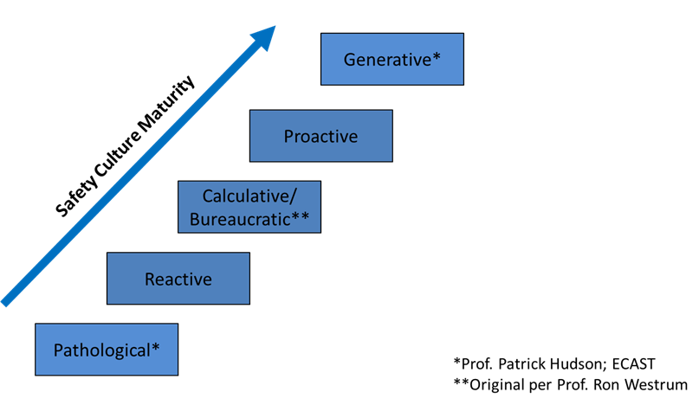

Figure 1. Safety Culture Maturity Levels: Original Form
Combining the Boundary Elements. The SMICG toolset to assess a service provider’s safety culture uses the middle three levels in an evaluation. The three elements in dotted line boxes in figure 2 refer to elements that were in the original ECAST model, but were not included in the final SMICG toolset.
These elements are also found, in a slightly different form, in measures of organizational capability. However, when viewed in terms of growth in safety management and safety culture maturity, the lowest level becomes an initial stage when an organization is just starting out, or one that has failed to grow. The elements of management are not significantly present in practice so there is nothing to evaluate.
The final level is one where proactive principles are continuously applied for the life of the organization. Therefore, there is no qualitative difference between the generative and the proactive level in terms of observable organizational behaviors.

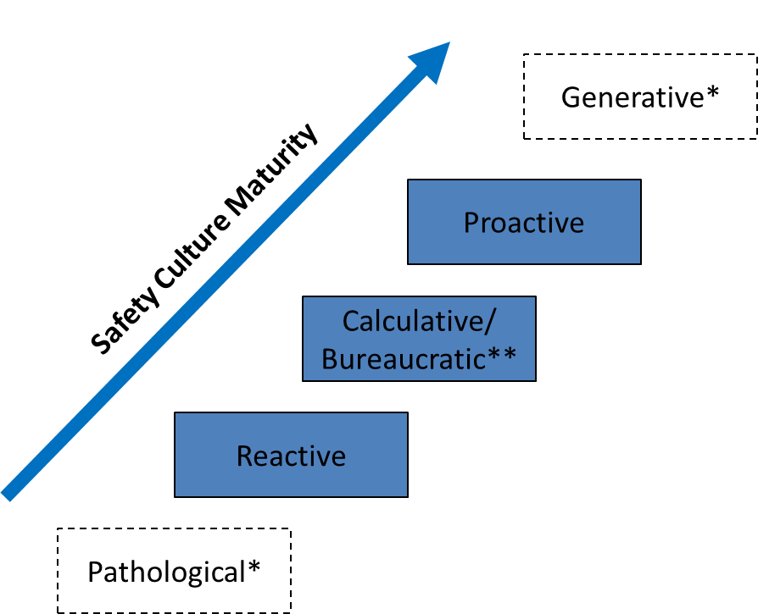

Figure 2. Safety Culture and Safety Management Maturity
Safety Culture Performance and Safety Management Capability. Safety culture and safety management capabilities are highly interdependent. As cultures grow and become more proactive in their approach to safety, their capabilities of managing safety also progress to higher levels of independent, inward-looking practices. Conversely, implementation of formal, well-defined safety management processes can support positive growth.

Growth in both areas are also highly dependent on the values, insight, and investments made by the organization’s leadership. Organizations can implement the basic processes of an SMS but may fail to realize the benefits or to grow into a truly proactive organization without the personal involvement and ownership of safety on the part of the organization’s leadership. Likewise, safety culture cannot be simply implemented or established as if it were a separate program. Cultures are the result of integrated, experiential learning on the part of an organization’s members, and they are guided by the values and behaviors of its leaders at all levels.
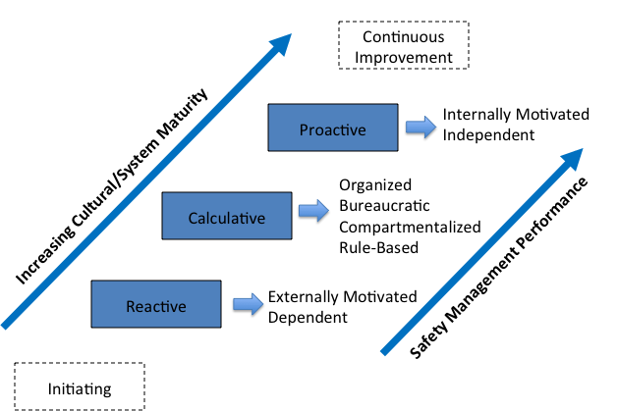

Figure 3. Maturity and External Motivation and Dependency
Phases of Maturity. As an organization moves through the levels of maturity, several characteristics tend to emerge. Figure 3 shows the culture model, annotated with some of the characteristics of each step. First, it is important to realize that the phases of maturity are cumulative rather than mutually exclusive. That is, they build on one another as an organization’s culture and systems grow.

Reactive Level. At the this level, an organization reacts to external inputs. These may be events such as accidents or incidents, compliance with rules, audit standards, or contractual requirements. Organizations that are strictly reactive may become dependent on their sources of inputs or the occurrence of events, rather than applying internal processes to find and address problems within their own organizations. They may also address inputs ad-hoc or as received, with unstructured or no internal systems.

Calculative/Bureaucratic Level. At the next level, organizations have structured organizational processes, management hierarchies and documented policies and procedures for essential functions. They specify expectations for behaviors and performance on the part of employees. These organizations may become more focused on adhering to bureaucratic requirements than determining the best method to address problems. Their bureaucracies may still be reactive, with processes focusing on administrating external inputs.

Proactive Level. As organizations become more proactive, they become less dependent on external inputs. At this stage, an organization’s culture and management capabilities are fully matured. While they have structured systems for managing performance and complying with regulations and other standards, they also use processes to monitor their own operations, detect problems, and find the best methods to address them. There is a general sense of accountability for safety across the organization. While collaborative to and receptive of outside inputs, such an organization is capable of working independently to identify and address safety issues.

Regulator/Service Provider Interdependence. Safe operations in the global aerospace system depend on effective compliance with regulations and management of unique hazards on the part of service providers. Safe operations also depend on a set of effective, consistent controls in the form of regulations and oversight activities based on a realistic understanding of the systems they oversee, as well as the level of maturity and safety management capability of individual service providers. Thus, there is a high degree of interdependence between regulatory authorities and service providers.

Flexible Oversight Approaches. Regulators should understand that typical populations of service providers cover the complete spectrum of cultures and capabilities described above. All may be acceptable within existing regulations. However, regulatory and oversight strategies should be based not only on a careful understanding of each service provider’s safety management capability, but also on the context and limitations of the regulatory and legal frameworks themselves.
For instance, reactive or calculative-reactive organizations may be fully compliant with prescriptive regulations and directive oversight, but may not have the capacity to make informed decisions and take appropriate actions without depending on external inputs. Clearly, these organizations will require a different style of oversight interface than organizations that have higher levels of internal safety management capability.

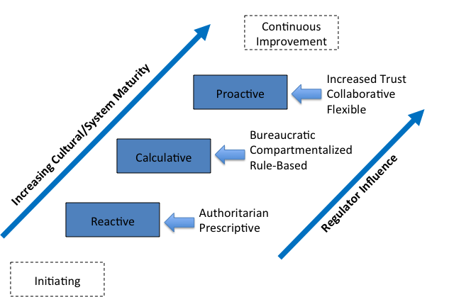
Fostering Growth. Given this understanding, regulators should also use it to foster growth of the organizations’ capabilities. Otherwise, they may inhibit practical innovation on the part of highly proactive organizations, or fail to provide those of lesser capacity with sufficient guidance. A regulator’s own culture and capability will affect their ability to adapt to these differences in service provider organizations.

Figure 4. Influence of Oversight

Figure 4 shows the effect of regulator influence on safety culture and management maturity of service providers as well as their oversight organizations. On the right side of the diagram are the regulator’s influences on the service providers’ processes. The influences depicted are examples only.

Oversight of Reactive Organizations. At the reactive level, regulator oversight is more authoritarian, referring to prescriptive regulations and compliance requirements. While this may be necessary if the service provider is at the reactive level, it does not encourage them to perform to a higher level. In fact, a service provider that is very responsive to regulator inputs may be simultaneously viewed as having a positive compliance attitude, or having little or no independent safety management capability.

Oversight of Calculative Organizations. Regulators, by the nature of their work, depend on bureaucratic processes to manage functions such as certification, approval, acceptance, or surveillance. They also expect to encounter a mature management system in service provider organizations in the form of manuals, defined positions, documentation and records. However, if the emphasis is strictly on compliance with the regulatory requirements with no regard to meeting the intended safety requirements, both parties may lose sight of the ultimate intent of the regulations and objectives. Authorities should make sure that their own bureaucratic processes are internally aligned and that they do not promote illogical responses on the part of service providers.

Oversight of Proactive Organizations. Proactive organizations develop and implement risk controls based on internally motivated, informed decision making. As controls are performance based, rather than prescriptive regulations and oversight, service providers should be innovative, while operators should apply critical thinking and flexibility in their oversight practices. Authoritarian, prescriptive, or overly bureaucratic regulatory and oversight approaches may inhibit growth into the proactive level. Regulators should develop and apply skills that foster these behaviors on the part of service providers while still ensuring consistency and public safety.

Defining Regulator Culture

With safety performance of service providers focusing on how well they manage safety risk in their operations, their safety culture embodies the automatic and consistent values, attitudes, and behaviors. The role of regulators is to perform oversight activities to provide assurance that service providers meet their responsibilities. To do so, regulators should understand the cultures of the service providers and adapt their oversight strategies to foster proactive practices and growth in their cultures. The Swiss Federal Nuclear Safety Inspectorate (ENSI) describes oversight culture, equivalent to the safety culture of the supervisory authority, in these terms:

Oversight culture comprises values, world views, verbal and non-verbal behaviours as well as specific products and work bases (e.g. the regulatory framework, demands, and formal orders) which are shared by the members of the supervisory authority. Oversight culture includes those values, world views, behaviours, products and work bases that determine or demonstrate how the members of the authority approach and deal with (…) safety in their oversight work .

Safety Culture Characteristics
The European Commercial Aviation Safety Team (ECAST) developed a safety culture framework consisting of six principal characteristics. These characteristics address patterns in the flow of information, decision making, employee behaviors, and management priorities. The six characteristics are:
- Behaviors
- Justness
- Commitment to Safety
- Adaptability
- Information
- Awareness.
When applied to regulatory organizations, the characteristics convey how effectively the regulator, its processes, and the activities of its personnel can influence not only product and service providers toward growth, but also their safety cultures and the continuous improvement of their safety performance.
Behaviors. What does the regulator emphasize in oversight – simple compliance with the letter of the law, or consistent patterns of behavior that reflect effective application of risk management? Does the regulator’s personnel treat service providers and their employees with professional respect and understanding?
Justness. How does the regulator treat non-compliance? Do they treat non-compliant performance punitively, or in a graduated way with an emphasis on finding the best way to restore effective risk control? Do its policies and personnel recognize that all problems are not intentional and that the willingness and ability to make meaningful corrections may be more effective than punishment, while still insisting on high safety standards? Does the regulator also promote just culture practices in the treatment of its own personnel?
Commitment to safety. Does the regulator facilitate effective risk management and assurance practices, or is it only reflecting a bureaucratic approach to administering the regulations? Does the regulator promote safety beyond the regulations?
Adaptability. Does the regulator promote innovative ways to achieve safety results on the part of service providers and agency personnel? Does its personnel consider requests for exemptions and deviations from prescriptive rules? What criteria do they apply? Does the regulator keep regulations and policies up-to-date and relevant?
Information. Does the regulator encourage a free and open flow of information? How do they treat safety information provided to them? Do they encourage the open exchange of information internally and externally? Do they make effective use of safety information in decision making?
Awareness. How does the regulator remain aware of emerging safety issues? How do they disseminate important safety information to the public and industry? Are they aware of how operations are actually performed by service providers beyond simple adherence to approved/accepted procedures? Do they ensure that certificate holders are made aware of potential problems discovered in oversight?
Assessment Methods
Many safety culture assessment programs focus only on interviews or surveys. While these tools provide valuable input into understanding the perceptions, attitudes, and opinions of an organization’s members, they do not provide a complete picture of an organization’s culture and the outcomes of its organizational behaviors. A multi-method approach is preferable to provide a more complete picture of the safety culture. The assessment should include:
- Reviews of policy and procedures
- Surveys/Questionnaires
- Interviews of management and workforce
- Case studies
- Field observations
- Oversight data
- Document reviews.

Figure 5 below depicts the assessment methods graphically. Note that while they all contributed to the overall assessment directly, they also interact to complement and validate each other.

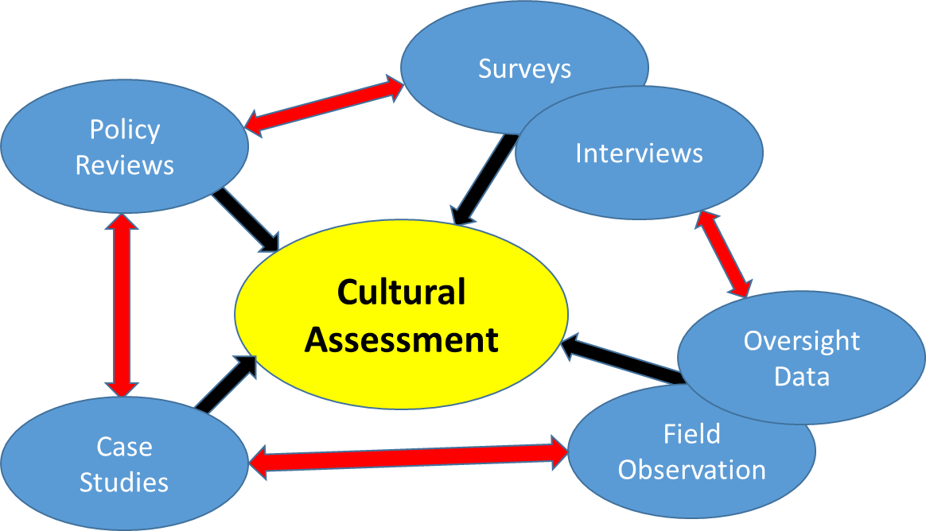
Figure 5. Assessment Methods

Planning to Collect Assessment Data
- Identify key areas of information desired. These may be focused on specific problem areas, changes, organizational units to be assessed etc.
- Develop Research Questions. Determine what you want to know and how it will be assessed before developing survey/interview questions, instructions for observations, objectives for document reviews etc.
- Ensure that all areas are covered in data collection planning (content validity)
- Select/develop data collection tools and methods
  - Consider using “word pictures” (also referred to as, “behaviorally-anchored ratings”) when developing evaluation scales. This approach uses descriptive narratives to provide evaluators with a means to compare (anchor) observed behaviors with prescribed levels of assessment. These rating scales provide users with descriptions of patterns of behavior or performance against which to compare observed conditions with levels of performance. Development of these scales should employ typical subject matter experts to ensure that the word pictures are expressed in the language of typical practitioners.
- Test tools and methods with typical users for inter-rater reliability to ensure consistency of results across users of the tools. Consider training, pilot testing, and discussions among tool users to reduce differences as well as to resolve discrepancies and potential misunderstandings.
Review of policy and procedures
Reviewing policies and procedures will provide a picture of the expected operation of the organization, its rules and specifications on how work is supposed to take place. This may be done well before other activities and may, in fact, be a basis for planning assessments. Particular attention should be given to observing differences between an organization’s published policies, procedures, and promotional material and its observed behaviors. Reviews of published policies and procedures can provide an initial impression of whether or not an organization has addressed important areas that could affect its organizational culture. Further observations should be conducted to validate the published policies and procedures versus actual practice.
Initial research for cultural assessments of regulators should also consider the legislative, regulatory, and higher-level policy structures under which the regulator operates. A regulator’s internal policies and procedures should also be reviewed, as in the case of service provider organizational and safety culture assessments. These factors should be carefully reviewed in terms of the regulator’s operational environment. A set of general expectations for the structure and functioning of the organization should result from his review, as well as a more concrete plan for further data collection, validation and analysis.

Surveys
Surveys are one of the easiest assessment tools to administer and analyze. They can also be administered remotely by electronic means, or by personnel with little or no training beyond the administrative procedures of distribution, maintaining privacy and security, and collection of completed tools and methods.
Information collected, however, may be narrower than other methods, which may channel the responses to those areas envisioned by the survey developers. This would exclude potential information that may otherwise be offered by members of the target population. Surveys also tend to measure organizational climate which may be of a more transitory nature than the more pervasive, enduring aspects of an organization’s culture.
Surveys will also be limited to the knowledge, experience, opinions and attitudes of those surveyed. While this is valuable information, it will reflect what respondents think is going on, but possibly not what is accurate. These perceptions may also be biased by social desirability effects where people may express what they believe is acceptable or avoid responses that they think would not be well accepted. Other respondents may also use the surveys as a means of making a statement. In all cases, the results of surveys should be validated by other means of data collection before making definitive conclusions about an organization’s culture.
One particularly useful approach can be to administer a concise general survey early in the assessment process to identify areas for additional emphasis using other methods. These may include areas in which additional information may be needed for clarification, areas with extreme or other unexpected response patterns, and areas that suggest that additional validation is advisable.

Interviews
Interviews provide a means for interacting directly with an organization’s personnel. They can be strictly scripted as a delivery method for a standardized set of survey questions, or they may be more open, allowing respondents to develop their own narrative. Cues or prompts may be used to stimulate the interviewees’ thoughts, but interviewers should take care not to contaminate the responses by leading the interviewee(s).
Structured questionnaire designs are more straightforward for analysis, but may not provide a complete picture of interviewees’ thoughts or knowledge, being limited to the information envisioned by those that developed the instrument. In this respect, they differ from surveys largely in terms of administration. One difference may be in how the interview items are framed. They can be direct questions to the respondent (What do you think… What have you seen… etc.). These items ask for direct, objective responses. Conversely, items may be an instruction directed toward the interviewer (What does the respondent think…). The items in these types of instructions provide the interviewer with an information requirement rather than a direct question. These types of items are more common when open-ended responses are desired, or when the interviewer prefers a narrative response from the interviewee. In both cases, they should be designed to obtain information from or about interviewees.
One advantage in this method of delivery over self-report surveys is that the interviewer can clarify questions when interviewees are having difficulty by either explaining the question or making additional inquiries. However, in these cases, interviewers should be careful not to provide too much information that may bias the interviewees’ answers. They should also be sensitive to maintaining the objectives of the interview items. Interview training, discussions, and dry-runs are helpful in maintaining inter-rater reliability.
Conversely, open narratives allow for discovery of information that was not considered when designing the survey or interview protocol, but they are more labor intensive to analyze and may lack comparability among respondents. In any case, interviews should address a specific set of information needs to address the research questions.
When multiple interviewers are used, training and calibration should be carried out to ensure consistency in recording and interpretation. This is particularly critical when open-ended surveys are used. When patterns of difficulty are found in in respondents’ understanding across respondent pools, interviewers should take detailed notes to assist in analysis and to improve tools for future use.

Case Studies
Case studies provide insight into the organization’s successes and problems as well as how they have handled them. These may include, but are not limited to:
- Accident and incident reports from regulators and/or accident investigation authorities (service providers)
- Internal investigation reports conducted by the organization itself (service providers)
- Internal/external audit reports including oversight reports (all)
- Summaries of actions taken on employee reports (all).
Case studies may be used to focus further data collection from assessment activities, or they may be used to validate the results of other data collection methods, such as surveys or interviews. Particular attention should be paid to the level of adherence to published policies versus actual practice. These might include:
- Does the organization conduct investigations into accidents and incidents?
- Does the organization investigate all incidents, or only those with serious outcomes?
- What is the focus of the organization’s investigations and their conclusions (e.g. to establish root causes or to asses culpability)?
- Does the organization have and use an employee reporting program?
- How active are the organization’s employee reporting systems?
- Do the regulator’s personnel and internal auditors look for an emphasis on safety awareness and objectives or simple compliance with prescriptive rules and policies?
- Does the regulator apply just culture principles in its interaction with service provider organizations and in actions involving its own employees?
- Does the organization apply just culture principles in investigating safety problems?

Field Observations
Inspectors and auditors place a great deal of emphasis on direct observation. Here, they observe actual performance of an organization’s members. However, the true test of a cultural assessment is in the ability to determine the likelihood that observed behaviors are representative of performance that can be expected when an organization’s members are not under observation. This is true of both service provider organizations and regulators.
Field observations can be used to validate other data collection and assessment methods and vice versa.
Validation and Assessment
Assessment of the culture of any organization should not depend on any one method. Results from each activity should be cross-referenced to gain additional insight from multiple sources. For instance, policies and procedures may provide information on what is expected to happen; surveys and interviews may tell us what employees think is happening (or possibly what they believe should happen); while records may tell us, what is happening or has happened in the past. Observations may also give evaluators insight into routine behaviors but may raise limited awareness as to why things are occurring as they are.
Assessments should also return actionable information to the organizations being evaluated. Numerical scores are of limited utility unless they can be interpreted in terms of actions taken to improve. Assessment reports should avoid relying on judgmental characterizations and adjectives that convey opinions, rather than objective facts that organizations can translate into action.
Another potential problem with scoring lies in the interpretation of numerical results. Since no objective thresholds for standardized scores are known to exist, the validity of such targets may be highly questionable. Changes in successively applying tools may also provide a sense of relative change over time, but organizations often concentrate on improving the issues discovered, not on simply raising a score. Nevertheless, it is easy for the score itself to become the objective rather than organizational performance improvements. For these reasons, numerical scoring of subjective assessments may be misleading and should be avoided.
Assessment processes also need not be considered a single comprehensive event. Different activities may be done in sequential fashion, with the results guiding subsequent activities. For example, surveys, when analyzed, may identify potential problem areas, and then follow-on activities such as document reviews, focus groups, focused interviews, may be planned to clarify or provide additional detail. A cultural assessment should be thought of as a continuing process, that is, one that monitors and guides the evolving maturity of the organization.

Appendix 1: Initial Safety Culture Survey for Authorities

This survey can be used to provide a preliminary picture of the opinions and perceptions of an Authority’s workforce. It should be used in combination with other assessment methods to validate the results and to clarify areas of interest. For further information, see Appendix 2 of this document.

- The Authority considers the effects their decisions have on service providers’ safety | 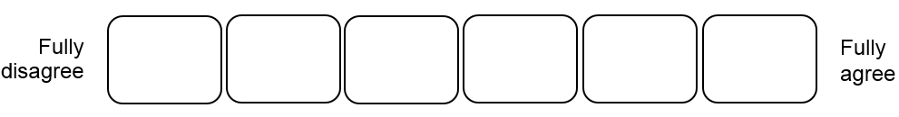
- Different Authority inspectors draw the same conclusions from the
same facts
- The different working units within the Authority work together effectively to achieve safety goals
- The Authority’s investigations do not focus on the mitigation of symptoms, but rather on the determination of root causes
- The Authority’s employees complete their tasks according to
standards and procedures
- The Authority’s management supports its employees’ decision-
making with regards to safety concerns
- Authority inspectors behave consistently when on the premises of a service provider
- Authority inspectors apply the same standards when conducting oversight
- When there is confusion on the meaning of a rule, the Authority has a mechanism to produce the intended interpretation of the rule
- The Authority’s working units share all relevant information with
each other
- The Authority has a decision-making process in place, which is based
on objective evidence
- Authority employees work collaboratively rather than independently
- The Authority’s culture allows for open discussions of problems
- The Authority’s working units are willing to take responsibility for safety problems
- The Authority’s employees feel comfortable to express their views to senior management without fear of negative consequences

- The Authority’s working units are aware of the tasks, competencies
and capabilities of the other units
- The Authority strives to identify its own weaknesses and takes steps
to address them
- Within the Authority, consistent opinions exist with regards to how oversight should be conducted
- Within the Authority, even complex safety issues are taken care of
- Within the Authority, it is easy to recognize which information is relevant to safety
- The Authority proactively identifies and mitigates industry safety risks
- There is a clear understanding of the professional relationship between representatives from the Authority and the service providers
- Authority working units pursue the same safety initiatives or decisions
- The Authority’s employees are made aware of relevant safety issues
and decisions discussed amongst the management
- The Authority’s management seeks and uses relevant safety information from employees before making decisions
- The Authority routinely assesses the effectiveness of its activities
- Priorities of the Authority are driven by safety goals rather than
political interests
- The Authority’s management and the employees share the same perspective on safety
- Within the Authority, employees accept constructive criticism
from colleagues
- Authority inspectors do not feel they need to cover their back when making decisions, because they can rely on management support
- Within the Authority, different opinions regarding a service provider
are resolved consistently and transparently
- Within the Authority, knowledge transfer functions well
- Management decisions are consistently implemented internally within the Authority

- The Authority’s management is in close touch with its employees
- The Authority’s employees eagerly express safety concerns
- The Authority’s inspectors do not apply personal prejudice when performing oversight activities
- The Authority’s decisions are not driven by pressures of public opinion
- The Authority does not blame its employees for honest mistakes
- The Authority does consider individual and organizational factors
when investigating internal problems
- The Authority does not accept work arounds from its employees

Any additional thoughts/comments?

Appendix 2: Using the Initial Safety Culture Survey
The Initial Safety Culture Survey for Authorities provides a means for gaining an initial impression of the opinions and perceptions of an authority’s workforce. This introductory survey will provide a preliminary means to identifying strong points, possible weaknesses, and insight into further data collection, validation, and analysis that could be conducted to clarify areas of interest.
An organization’s culture comprises both internal attributes (how people in the organization are integrated and how they interact) and external attributes (how the organization and its members interact with other organizations and their members). In the case of regulators, the external attributes are especially important as they are resonated in the authority’s interactions and influence on the service providers that they oversee as well as other regulated stakeholders, such as pilots and technicians holding licenses issued by the authority.
Each question on the survey represents a different subject so users should avoid rolling up responses into an aggregate score. Analysis of individual questions allows users to better identify potential strengths and weaknesses. Aggregate scores are not reliable (questions may cancel each other out) and difficult to interpret in terms of actionable information.
Users should consider stratifying the survey effort across levels such as senior managers, middle/front line managers, and front-line employees. Research has shown that these groups often have different perspectives and perceptions of what is happening in an organization. This is a special area where users should be vigilant for spreads in ratings between user groups. This could signify problems with communication, priorities, or differences between policy, procedure, and actual practice.
During analysis, users should look for items where there is considerable spread in the ratings. This could signify problems with interpreting those particular questions, or it might suggest that there are different patterns of opinion in different areas of the organization, such as different departments, technical disciplines, or at professional or managerial levels.
Responses should be validated by conducting appropriate comparison between levels in the organization and responses on surveys, which are particular areas where objective data can be compared. For example, a question on the focus of investigations (e.g. finding responsible parties and assessing blame vs. identifying root causes) may be answered differently by senior management and front-line employees. If reviews of investigation reports indicate that the results predominantly identify employees’ actions as the cause, a different conclusion might be drawn if the reports routinely find problems with procedures, training, facilities etc. In these cases, users should not assume a lack of forthrightness on the part of survey respondents, but rather a possible lack of awareness concerning what is really going on versus what is thought to be the case.
Appendix 3: Sampling for Interviews and Surveys
- Sampling plans for respondent selection should include interviewees selected both horizontally and vertically across the organization. Selected respondents across equivalent peer groups should take into account the technical as well as the technical/professional peer groups and work units because these divisions may contain subcultures with distinct differences in experiences and knowledge.
- Sampling should also consider the different perspectives that are likely in progressively higher levels of management and staff. These differences should be recognized in the regulator’s understanding of the cultures of the organizations that they oversee, the influences that their practices make, and in the regulator’s own organization.
- Senior management is responsible for overall performance of all aspects within the organization. These managers are ultimately responsible for the organization’s accomplishment of its overall purpose – its mission. They will also be accountable for safety, resource allocation, and, in commercial enterprises, return on investment. The have (or should have) the big picture in mind, but it may lack details. Their perspective may, therefore, differ from people in progressively more focused roles.
- Functional and front-line managers are those that are progressively closer to front-line employees. While they are responsible for the mission, resources, and safety, they tend to operate under more constraints. They must operate with specifically allocated resources, perform and supervise specific tasks, and assure front-line safety. Their roles may be highly compartmentalized. Key markers of an effective organization are situations in which the level of necessary interdependence among work units is well understood and practiced, and in which information flows are open and effectively used for tactical decision making. These managers may have more details than and different perspectives to senior managers or front-line employees, but their knowledge, experiences, and perceptions may be limited to their areas of responsibility.
- Front-line employees are those tasked with the direct labor related to mission accomplishment. In their positions, they are the most likely to see differences between stated or aspirational values in published organizational documents and policies, and actual practice. They are also most likely to see problems between system expectation in areas such as task design, procedures, scheduling, and available resources. Theirs is the area in which work as envisaged may clearly differ from work as done.
- Front-line employees will generally behave according to the organization’s norms and expectations, with priorities given to the pressures from management and the need to meet them. They may not even be distinctly aware of the balance, having learned what is most successful in their experience and observing peer experiences.
- Effective organizations with mature cultures are attentive to the difference between system design expectations, assumed environments and work as it is actually performed in the environments that actually exist. They actively seek to find out and act on differences between assumptions and reality. This is reflected in their reporting, monitoring, auditing, and assessment processes, as well as the attention management gives to this information when making decisions.

The SM ICG Safety Culture pamphlet can be downloaded at: https://www.skybrary.aero/index.php/Safety_Culture_for_Effective_Safety_Management
The SM ICG Safety Culture Evaluation Tool and Guidance for Industry can be downloaded at: http://www.skybrary.aero/index.php/Category:SM_ICG_Guidance/Tools
The SM ICG Safety Culture pamphlet can be downloaded at: https://www.skybrary.aero/index.php/Safety_Culture_for_Effective_Safety_Management
See ICAO Annex 19, paragraph 3.4, “State safety assurance,” as well as Annex 19, Appendix 1, with particular reference to paragraphs 1 and 6-8.
Piers, Montjin & Balk (2009). Safety Culture Framework for the ECAST-WG.
The SM ICG Safety Culture Evaluation Tool and Guidance for Industry can be downloaded at: http://www.skybrary.aero/index.php/Category:SM_ICG_Guidance/Tools
The revised structure was developed by the Swiss Federal Office of Civil Aviation (FOCA).
ENSI; Oversight Culture 2015, ENSI Report on Oversight Practice, available at: https://www.ensi.ch/en/documents/oversight-culture-2015-ensi-report-on-oversight-practice/
Additional information on assessment methods can be obtained in Patankar, Brown, Sabin & Bigda-Peyton (2012) Safety Culture, chapter 2.
Dr. Edgar Schein, MIT refers to these as “Espoused values,” which are those values expressed in documents but that may not be practiced. Schein, E. (2009) The Corporate Culture Survival Guide.
For example, reporting policies, focus of internal investigations (blame vs problem solving), responsibilities of personnel etc.
Information to consider for survey/interview sampling plans can be found in Appendix 3.
A sample survey instrument is provided in Appendix 1.
Researchers should be aware and respectful of confidentiality policies.
This applies to service providers’ internal processes, the investigative and auditing processes of the regulator with respect to service provider organizations, and to the regulator’s handling of incidents and performance of its own personnel.
Senior managers may have considerable filters for information. At the same time, they should foster organizational processes and behaviors that provide them with a realistic picture of important front-line issues in order to make essential decisions in the areas of production, resource management, finance, and safety. A key marker of an efficient organization is not necessarily whether executives have all of the information possible, but whether they have the right information for effective decision making.

