
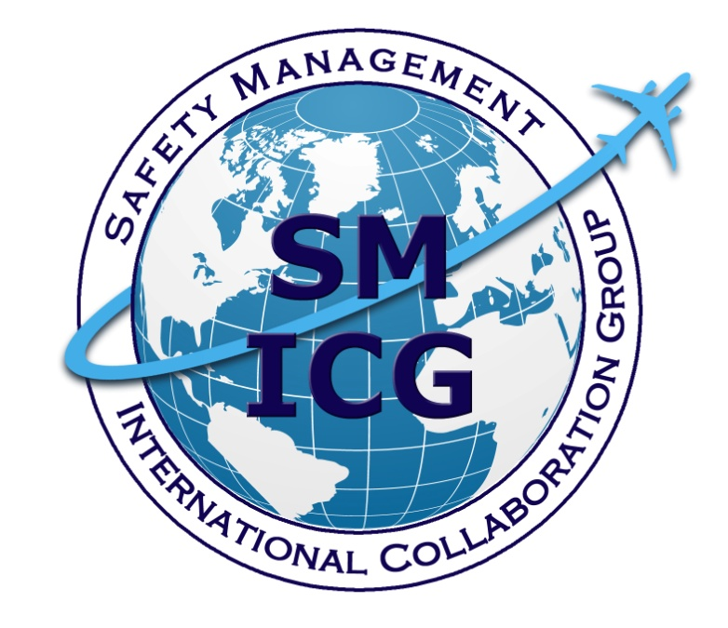
May 2021
Safety Management System (SMS) Integration: Points to Consider

This paper was prepared by the Safety Management International Collaboration Group (SM ICG). This paper was prepared by the Safety Management International Collaboration Group (SM ICG). The purpose of the SM ICG is to promote a common understanding of Safety Management System (SMS)/State Safety Program (SSP) principles and requirements, facilitating their application across the international aviation community. In this document, the term “organization” refers to a product or service provider, operator, business, and company, as well as aviation industry organizations; and the term “authority” refers to the regulator authority, Civil Aviation Authority (CAA), National Aviation Authority (NAA), and any other relevant government agency or entity with oversight responsibility.

The current core membership of the SM ICG includes the Aviation Safety and Security Agency (AESA) of Spain, the National Civil Aviation Agency (ANAC) of Brazil, the Civil Aviation Authority of the Netherlands (CAA NL), the Civil Aviation Authority of New Zealand (CAA NZ), the Civil Aviation Authority of Singapore (CAAS), Civil Aviation Department of Hong Kong (CAD HK), the Civil Aviation Safety Authority (CASA) of Australia, the Direction Générale de l'Aviation Civile (DGAC) in France, the Ente Nazionale per l'Aviazione Civile (ENAC) in Italy, the European Aviation Safety Agency (EASA), the Federal Office of Civil Aviation (FOCA) of Switzerland, the Dominican Republic Civil Aviation Institute (IDAC), the Finnish Transport Safety Agency (Trafi), the Irish Aviation Authority (IAA), Japan Civil Aviation Bureau (JCAB), the United States Federal Aviation Administration (FAA) Aviation Safety Organization, Transport Canada Civil Aviation (TCCA), United Arab Emirates General Civil Aviation Authority (UAE GCAA), and the Civil Aviation Authority of United Kingdom (UK CAA). Additionally, the International Civil Aviation Organization (ICAO) is an observer to this group.

Members of the SM ICG:
- Collaborate on common SMS/SSP topics of interest
- Share lessons learned
- Encourage the progression of a harmonized SMS/SSP
- Share products with the aviation community
- Collaborate with international organizations such as ICAO and civil aviation authorities that have implemented or are implementing SMS and SSP

For further information regarding the SM ICG please contact:
Claudio Trevisan Andrew Larsen Eugene Huang
EASA TCCA FAA, Aviation Safety
+49 221 89990 6019 (613) 993-9158 (202) 267-7577
claudio.trevisan@easa.europa.eu andrew.larsen@tc.gc.ca eugene.huang@faa.gov

Neverton Alves de Novais Charles Galea
ANAC CASA
+55 61 3314 4606 + 07 3144 7487
Neverton.Novais@anac.gov.br Charles.Galea@casa.gov.au

SM ICG products can be found on SKYbrary at: http://bit.ly/SMICG

To obtain an editable version of this document, contact smicg.share@gmail.com.

Purpose
The purpose of this document is to provide the reader with best practices concerning the integration of multiple management systems within organizations. The document considers multiple scenarios relating to the integration of operating systems and does not exclusively deal with safety management systems (SMS). It does, however, cover many key areas that might require attention and review and provides the reader with advice in respect to successful systems integration.

Additionally, this document provides guidance to other regulators in respect to the integration of other legislated and non-legislated systems (e.g., occupational health and safety, environment) into the safety management environment. In addition, it covers a variety of integration scenarios and offers useful tips on how to deal with these situations.

Objective
The objective of this document is to promote a harmonized approach to implementation and oversight of integrated systems and promote a performance-based approach to assessing management system effectiveness.

The effective integration of systems is expected to enhance efficiency and effectiveness of safety risk management. Promoting ways to integrate SMS with other types of management systems will also allow for more support of SMS.
This guidance document outlines:
- What integration means in practice (e.g., accountabilities, policy and objectives, resources, processes and tools);
- Areas that require particular attention during integration in order to maintain organizational capability in terms of effective Safety Risk Management (SRM);
- A mechanism for the service provider (SP) to demonstrate to the regulator a fully integrated SMS, thereby allowing the authority to properly discharge its oversight responsibilities; and
- Best practices, cautions and possible solutions as they relate to specific scenarios and defined issues.

Problems Related to Systems Integration
The following define some of the issues that commonly exist related to integration.

Integrated Management Systems
Statement of Issue: This section discusses the issues related to the integration of various management systems within one SP. There are multiple facets to consider, including the integration of management systems with those required by other legislative or regulatory requirements, such as occupational health and safety, security, environment and quality management systems (QMS). It may also include the integration of non-regulated systems such as finance and human resources.

Guidance
The regulator should consider the following when assessing the integration of multiple management systems into the service provider’s (SP) SMS:
- Effective integration is possible if the following exist:
- The authority possesses policies/legislation that identify the scope of the authority oversight. It should be noted that in some cases, the civil aviation authority may not be responsible for the oversight of all the subordinate management systems. In that case, bridging documents may be required to address the requirements of each system.
- The SP has clearly documented the management systems that are being integrated and how the individual requirements are met, managed, and maintained.
- There is evidence that the SP is using industry standards related to the integration of management systems including the ISO High Level Structure (HLS) standard, the International Air Transport Association (IATA) Integrated Airline Management System (IAMS), or similar standards.
- Personnel performing oversight functions within the authority have the expertise and have been provided the necessary training to oversee a SP with an integrated management system.
- The authority possesses processes, procedures and tools necessary to oversee an SP with an integrated management system.
- The authority possesses the resources necessary to oversee service providers with integrated management systems.

- Is the integrated management system, including the SMS, appropriate and adequate given the following considerations?
- The integrated management system clearly identifies accountabilities and responsibilities.
- The SP has documented how the management systems are functionally linked and identified how the systems interface with each other and with the integrated management system.
- Evidence exists that the SP dedicates the necessary priorities and resources for the integrated management system and for each of the interacting management systems.
- The SP clearly identifies and documents how it will address multiple inputs from and to the interacting management systems.
- The SP assesses the effectiveness of its integrated management systems and modifies the system as a result of changes and lessons learned, as appropriate.
- The SP possesses processes/tools to allow each authority to oversee the management system in its area of responsibility.

Multiple Certificates
Statement of Issue: This section discusses concerns related to the integration of multiple certificates with SMS requirements held by an individual organization.

Guidance
The regulator should consider the following:
- Ensure that SMS oversight policies and processes are consistently applied throughout the State.
- There should be evidence of management commitment for consistent application of oversight.
- All oversight personnel should be provided standardized training.
- All the oversight organizations should utilize standardized policies, procedures, and auditing tools.
- There should be consistent and frequent communication between the responsible units.
- Mechanisms should be in place to monitor the degree of standardization of oversight activity and there should be evidence that the system is continuously improved.

- Ensure awareness that organizations with multiple certificates may elect to implement one SMS.
- Recognize that SMS can be tailored, as appropriate, to the individual SP. The SP should show how these systems are compatible with the parent organization’s SMS.
- Recognize that the SMS in each SP may be integrated into one high level system at the parent level.
- Be aware that when the parent organization manages both domestic and international certificates, this scenario can introduce additional challenges such as reciprocity between different authorities.
- Ensure that the SP has documented its policies and procedures on how data is shared, communications are relayed, decisions are made, and resources are allocated.
- Each SP should clearly document the roles and responsibilities associated with its SMS and the hierarchical or accountability framework for the SMS.
- The SP should demonstrate how its SMS-related voluntary agreements work between its parent organization and its sister organizations, as appropriate, and vice-versa.
    - A policy or other documentation should exist that identifies these relationships.
    - Evidence exists that the voluntary agreements are adequately communicated within the affected organizations.
    - Evidence exists that this type of information is shared between the organizations.

Multiple Organizations (in the Aviation Community)
Statement of Issue: This section discusses the issues related to interoperability of individual SMSs in situations where multiple organizations interact in a particular operating environment. This may include:
  - The linkage between the airport, airlines, air traffic management (ATM) and third parties;
  - The relationship amongst code sharing and/or alliances airlines;
  - The linkage between airlines and non-certificated third parties; and
  - Airlines and manufacturers.

Guidance
The regulator should consider the following:
- Each SP defines its roles, responsibilities, and its relationship with the various stakeholders of concern. The SP also identifies who will take the lead in facilitating SMS activities, realizing that there may be no regulatory imperative to share information.
- The SP possesses documented policies and processes that address how it will deal with the management of change at its organization and other related stakeholders, when appropriate.
- The SP policies and processes are clearly documented and communicated.
- Evidence exists that each service provider’s SMS is well understood by all stakeholders and differences between stakeholders are reconciled to promote a common understanding of hazards, risks, incidents, etc.
- For example, an airport safety committee facilitates exchange of information collected by individually operated SMSs to assist in identifying hazards that may impact multiple entities.
- SMS related voluntary agreements should exist among stakeholders.
- Processes are present that enable the sharing of information derived from these systems among the various stakeholders.
- Evidence exists that stakeholders are sharing safety relevant information among themselves.
- Possible mutual activities or areas of cooperation which may have potential implications resulting from any bilateral agreements and arrangements entered into by authorities and/or other signatory parties.

Outsourcing SMS Elements
Statement of Issue: This section discusses the issues related to the outsourcing of elements of the SMS to another entity that may or may not be regulated.

Guidance
The regulator should consider the following:
- The SP identifies all the entities that are responsible for managing SMS components on its behalf.
- A formal agreement exists between the SP and the organization that is providing outsourced services.
- Evidence exists that the outsourced organization possesses the appropriate qualifications to undertake the outsourced services.
- The service provider’s SMS should clearly identify that SMS accountability always remains with the SP.
- Evidence exists to demonstrate the appropriateness of the outsourced SMS components.
- It should be recognized that certain elements of SMS should not be outsourced such as policies, management accountability, and management actions.
- The SP has clearly documented the roles and responsibilities between itself and organizations that provide the outsourced services.
- The SP and the organization that provides the outsourced services share pertinent data/information and possess documented processes to enable the sharing of this data/information.
- Evidence exists that the SP assesses the effectiveness of its overall SMS, including ensuring that the outsourced elements are not weak links within its SMS.

Outsourcing Activities – Regulated Entities
Statement of Issue: This section discusses the issues related to the outsourcing of regulated functions such as maintenance, design, manufacturing, and training, to other SPs and external entities.

Guidance
The regulator should consider the following:
- A formal agreement exists between the SP and the organization that is providing outsourced functions. The agreement should be revised appropriately and in a timely manner when the scope of outsourcing changes or when the organization of either entity changes, for example.
- The SP maintains accountability as related to SMS for outsourced activities and it is described in the service provider SMS or other suitable documents.
- The service provider SMS is effectively linked with the safety management systems of organizations that provide outsourcing, despite the possibility of being substantially different.
- The SP has documented how it shares information on hazards, risk analysis, and risk management with organizations that provide outsourced functions. It is agreed upon and shared between stakeholders.
- Evidence exists that the SP manages multiple inputs and outputs from all organizations that provide outsourced functions.
- The SP manages multiple interfaces and communication between various stakeholders effectively.
- If a task is outsourced to a non-certificated entity, then appropriate agreements exist between the SP and the non-certificated entity to allow for sharing of information on hazards, risk analysis, and risk management.

Outsourcing Activities – Non-regulated Entities
Statement of Issue: This section discusses problems related to the assignment of non-regulated activities to third party entities that are not required to have an SMS such as catering, fueling, baggage handling, and other ramp services.

Guidance
The regulator should consider the following:
- The SP should possess appropriate agreements with non-regulated entities that provide services, regarding sharing of information on hazards, risk analysis, and risk management.
- The regulator should encourage the industry to utilize newly developed industry guidance material regarding this topic including the IATA Safety Audit for Ground Operations (ISAGO), the IATA Airport Handling Manual and the European Commercial Aviation Safety Team (ECAST) Ramp Resource Management document.
- Voluntary sharing of information should be encouraged as it can be beneficial to safety (safety promotion).

State Safety Program (SSP) and Safety Management Systems Integration
Statement of Issue: This section deals with SMS integration in relation to the State Safety Program (SSP). There are numerous interfaces that need to be considered. They include: safety data collection, assessment, and exchange; safety oversight (compliance, risk, and performance based); safety culture development; and finally, the interface between the State’s overall safety objectives and the stakeholder’s actual safety performance. The stakeholder’s safety performance should be congruent and consistent with the expectations defined by the State in its safety objectives, goals, and indicators.

Guidance
The regulator should consider the following:
- An open and effective reporting culture needs to be fostered at the State and stakeholder level.
- Legal provisions for a “just culture” approach are essential to effective SMS implementation and integration.
- Recognize that linkages exist between the safety performance of the industry and the State.
- The State needs to clearly articulate what its expectations are with regards to stakeholder safety performance.
- For each SP assess the appropriateness of its safety metrics and recognize how it may link back to the State safety objectives, goals, and indicators.
- Provide training to oversight staff so that they become familiar and understand how the State and the SPs define and apply safety performance indicators (SPIs).
- The State should have the capability to identify and assess all “3 Tier” (SM ICG SPMA) safety performance indicators, as described in the Safety Management International Collaboration Group (SM ICG) document, A Systems Approach to Measuring Safety Performance – The Regulator Perspective.
- Safety culture development and safety promotion activities can be enhanced when coordinated between the State and stakeholders.

General Issues Applicable to all Entities
Statement of Issue: This section deals with issues that may be applicable to all the SMS integration issues identified in Sections 3.A through 3.G above.

Guidance
The regulator and the service provider should consider the following:
- Appropriate training regarding integration should be provided to both the regulator staff and regulated service providers.
- The introduction of SMS throughout the industry will mean that the State oversight will evolve from compliance based to performance based. This is not a “turn-key” process and needs to mature over time. Allowances should be made accordingly.
- The influence of culture and human factors should be given due consideration, including issues such as language, norms, and behaviors.
- The importance of a reporting culture (data/safety information sharing), including issues with sharing proprietary information and protection of data, should be emphasized.
- To promote effective communication, adequate interfaces should exist between all stakeholders; and interfaces should be kept as simple as possible.
- The SP is always accountable for its SMS regardless of whether it is outsourcing SMS activities or other regulatory requirements.
- The scalability of SMS should always be considered for both large and small organizations and how they may interact with other SMSs, when appropriate.
- All the guidance in this document should be considered whether the certificates are held domestically or internationally.
- The regulator and industry should note that foreign SPs may be subject to different policies/regulations regarding SMS, data protection, and data sharing. The provisions of bilateral agreements, and the terms of such agreements, would normally prevail in these circumstances. As such, the regulator should consider these issues when developing bilateral agreements.

Further Information
SMS integration is an admittedly broad theme with several aspects that must be taken into consideration from both States and Service Providers perspectives. In this sense, this document was prepared based on the experience of Safety Management International Collaboration Group (SM ICG) members and it is recognized that complementary materials may provide the reader with additional information on the subject.

Additional SM ICG products can be found on SKYbrary at: https://www.skybrary.aero/index.php/Safety_Management_International_Collaboration_Group_(SM_ICG)

To obtain an editable version of this document, contact smicg.share@gmail.com.

