The Frontline Manager’s Role in
Safety Management Systems

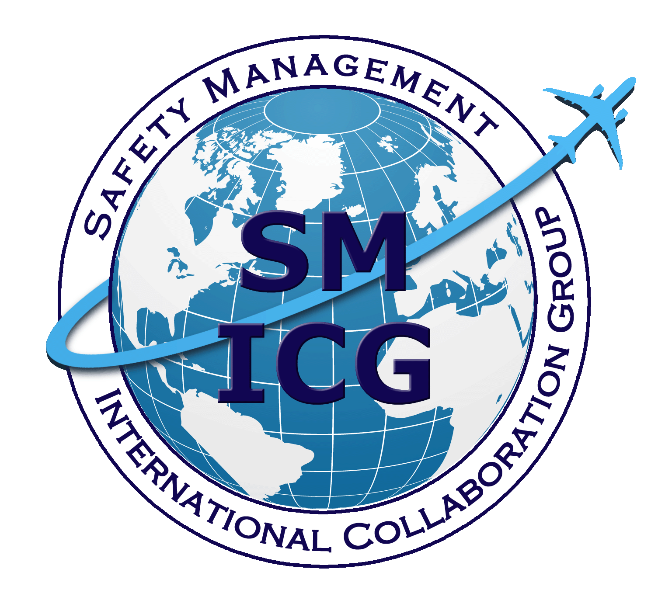

May 2016
This paper was prepared by the Safety Management International Collaboration Group (SM ICG). The purpose of the SM ICG is to promote a common understanding of Safety Management System (SMS)/State Safety Program (SSP) principles and requirements, facilitating their application across the international aviation community. In this document, the term “organization” refers to a product or service provider, operator, business, and company, as well as aviation industry organizations; and the term “authority” refers to the regulator authority, Civil Aviation Authority (CAA), National Aviation Authority (NAA), and any other relevant government agency or entity with oversight responsibility.
The current core membership of the SM ICG includes the Aviation Safety and Security Agency (AESA) of Spain, the National Civil Aviation Agency (ANAC) of Brazil, the Civil Aviation Authority of the Netherlands (CAA NL), the Civil Aviation Authority of New Zealand, the Civil Aviation Authority of Singapore (CAAS), the Civil Aviation Safety Authority (CASA) of Australia, the Direction Générale de l'Aviation Civile (DGAC) in France, the Ente Nazionale per l'Aviazione Civile (ENAC) in Italy, the European Aviation Safety Agency (EASA), the Federal Office of Civil Aviation (FOCA) of Switzerland, the Finnish Transport Safety Agency (Trafi), the Irish Aviation Authority (IAA), Japan Civil Aviation Bureau (JCAB), the United States Federal Aviation Administration (FAA) Aviation Safety Organization, Transport Canada Civil Aviation (TCCA) and the Civil Aviation Authority of United Kingdom (UK CAA). Additionally, the Civil Aviation Department of Hong Kong (CAD HK), the International Civil Aviation Organization (ICAO), and the United Arab Emirates General Civil Aviation Authority (UAE GCAA) are observers to this group.
Members of the SM ICG:
- Collaborate on common SMS/SSP topics of interest
- Share lessons learned
- Encourage the progression of a harmonized SMS/SSP
- Share products with the aviation community
- Collaborate with international organizations such as ICAO and authorities that have implemented or are implementing SMS and SSP

For further information regarding the SM ICG please contact:
Regine Hamelijnck Jacqueline Booth Amer M. Younossi
EASA TCCA FAA, Aviation Safety
+49 221 8999 000 (613) 952-7974 (202) 267-5164
regine.hamelijnck@easa.europa.eu jacqueline.booth@tc.gc.ca Amer.M.Younossi@faa.gov

Igor Penna Mike Hutchinson
ANAC CASA
+55 613 3144 826 +03 9518 2774
igor.penna@anac.gov.br Mike.Hutchinson@casa.gov.au

SM ICG products can be found on SKYbrary at: http://bit.ly/SMICG

To obtain an editable version of this document, contact smicg.share@gmail.com.
Foreword
This document has been developed by the Safety Management International Collaboration Group.
Although senior managers are ultimately responsible for managing the SMS, it is you, the frontline managers and supervisors, who have to implement the safety activities at the sharp end. Every day you and your team are faced with operational hazards and risks. As a result, you are constantly managing the many internal and external pressures of delivering a service safely.
It is your involvement and contribution to safety management that is essential to the success of the organisation’s SMS.
We hope that by reading this, you will get a better understanding of what a Safety Management System is and the important role you play within it.

“Management focus is the key to quality safety performance. Like all other management functions highly effective leadership is essential…” George Robotham, 2012

What is a safety management system?
There is a common misperception in aviation about where safety sits in the organization. Many have traditionally believed that safety happens and belongs on the flightdeck, on the ramp or in the hangar. Others would argue that safety is the responsibility of senior management. In reality, safety is a shared responsibility across the whole organization.
The frontline manager, he or she has to deal with the realities of delivering products and services on time whilst also ensuring that they are delivered safely. Few could argue that the implications of poor safety decisions or behaviors are evident in line operations, production and maintenance, but where does the ownership of safety sit?
The introduction of SMS places the ownership of safety and safety culture directly in the hands of management. This means management at all levels and not just the accountable executive or the Senior Managers. Turning the safety commitment into actions occurs at the level of the frontline manager. This is where priorities are implemented, resources distributed and the safety message walked and talked.
More importantly, it is at this level of management where the safety culture of the organization is reinforced: A frontline manager leads by example, demonstrating the common set of beliefs and behaviors that provide the foundation for a good safety culture.
Regardless of the nature of the products and services that organizations deliver and the competing demands, safety must be a priority. It makes sense from a practical perspective and is a must from a moral and legal perspective. The Frontline Manager needs to understand the legal implications in respect to the role they play.
Proactive safety management practices provide the frontline manager with the knowledge they need to understand hazards and risks in their daily operations. Moreover, from a legal perspective, making every effort to know everything you can about your hazards and risks and taking appropriate action demonstrates that you did everything you could to manage the safety risks of the operation.
“The immediate cause may be human or technical failure, but these in turn usually stem from organisational failures which are the responsibility of management.”

The Rt Hon Lord Cullen PC, The Ladbroke Grove Rail Inquiry, 2000.

Safety management systems defined
A safety management system is a businesslike approach to safety. It is a systematic and proactive process for managing safety risks. As with all management systems, it provides goal setting, planning, and performance monitoring. A safety management system is woven into the fabric of an organization. It becomes part of the culture, the way people do their jobs.
What a safety management system is - practically
Managing safety is really about managing safety risk, which means trying to prevent bad things from happening, or if something does go wrong, or slips through the cracks, trying to minimise the consequences of the event.
Safety management is about accepting that things will go wrong regardless of whether you believe you have robust processes and procedures. The frontline manager is closest to the people using these processes and procedures. They are ideally placed to identify weaknesses and potential risks in order to take appropriate action and measure how well risk controls are working.
What a safety management system isn't – practically
A safety management system is not the same as a Quality Management System (QMS), although they do share many of the same features and capabilities, such as performance targets, reporting, governance and performance monitoring. The objective of a QMS is the control of processes to achieve predictable and desirable results that meet with the customer’s and organization’s requirements. Whereas the objective of an SMS is to monitor and control operational safety risks, and to improve the organization’s safety performance.
If your organization has a functioning QMS, then your staff will already be familiar with the basic features of a management system—which is vital to the implementation, sustainability and integration of your SMS.
Finally, the SMS is not just a manual, a database, or a reporting process; these are all tools. It is how safety is managed day to day and becomes part of your organization’s culture. To be effective, it should penetrate into the operation’s processes and activities and facilitate informed decision making. It is a vital management tool and for it to be effective it relies upon you to encourage reporting and provide feedback as your staff are the eyes and ears of the organization. The SMS is the decision-making ‘brain’ of the system and you are responsible for ensuring the right information gets to the right people.

Why you should be involved:
a practical perspective
Primarily, your SMS gives you control over the safety risks in your day-to-day activities. As a frontline manager you are responsible to senior management and other stakeholders to ensure the business is running efficiently and safely. You are the risk managers and it is what you do every day.
SMS formalizes the decision-making process and provides a mechanism for assessing whether the risk is acceptable or not. It can support you with the management of risk. Without a framework, how can you assure yourself, and your staff, that the risks are acceptable? How do you know—objectively—when to ‘go’ or ‘not go’? And how would you defend your operational risk decisions to senior management without a structured framework?
An effective safety management system provides you with many other potential benefits, including:
- A clear and documented approach to achieving safe operations that is translated into work practices
- Better participation of staff in safety leading to an increased sense of commitment to the organization
- A positive safety culture
- A clearer understanding of the organization’s safety objectives and how you and your teams contribute to safety improvements
- Improvement of processes and procedures to increase operational efficiency
- The ability to support and justify decision making
- Better protection when things go wrong

The managers most responsible for a company’s success or failure happen to be the ones with whom the CEO spends the least amount of time. The people I’m talking about are frontline managers…It is the frontline managers who must motivate and bolster the morale of the people who do the work—those who design, make, and sell the products or deliver services to customers. These managers are central to a company’s [safety] strategy because they oversee its execution. They represent an all-important feedback loop that allows the CEO to stay abreast of the latest developments….

Fred Hassan, The Frontline Advantage, Harvard Business Review

Who is the Frontline Manager?
A frontline manager can be a supervisor, team leader, project leader or a middle manager. Typically, they are at the first level of management. In a smaller organization they may manage one or two employees, in larger organizations they may have many more employees reporting to them. These employees usually have no management responsibility themselves. So it is the frontline manager that guides and directs their team in the performance of their tasks.

Over the past decades, the frontline manager has become more than a task master who monitors and controls work. They are often required to administer additional tasks such as counselling, employee management, disciplinary action and measuring performance and the focal point for communicating issues. The role has evolved into a critical function within the organization and is pivotal in respect to safety and the organizational culture.

What’s Driving SMS?
Your authority is required by the International Civil Aviation Organization (ICAO) to implement SMS. ICAO has also introduced state safety program (SSP) requirements. Essentially, the SSP provides a mechanism for your authority to identify, manage and monitor safety risks at a national level. If you think about it, this is similar to the SMS your organization has implemented. Your SMS provides vital safety risk information for the improvement of aviation safety in your country.
SMS is also driven by a recognition that, in spite of the already good safety record in aviation, there is always room for improvement. It is expected that as air traffic movements continue to grow, if we do nothing more there will be an unacceptable increase in incidents and accidents.. SMS is a proactive response to this reality and to the increasing complexity of aviation operations. In 1997, James Reason published Managing the Risks of Organizational Accidents. Reason argued that improving the aviation safety record, addressing both the human and organizational factors that lead to accidents, is critical.
“There are two kinds of accidents: those that happen to individuals and those that happen to organizations. Individual accidents are by far the larger in number…[organizational accidents] are comparatively rare, but often catastrophic, events that occur within complex modern technologies…”
“Organizational accidents have multiple causes involving many people operating at different levels of their respective companies…Organizational accidents are the product of recent times, or more specifically, a product of technological innovations which have radically altered the relationship between systems and their human elements.”
James Reason, Managing the Risk of Organizational Accidents, Ashgate Publishing, 1997.
How you get involved:
Leading by example
Lead from the front
As a frontline manager, you have a significant role to play in maintaining the effectiveness of the SMS and encouraging active participation. In concert with this, you play a critical role in maintaining a positive safety culture when you lead by example. You must not only be committed to your organization’s SMS, but you must also be seen to be committed; you must translate the principles and concepts of SMS into your day-to-day activities. You can do this by applying risk management practices into your decision making as well as encouraging staff participation through reporting, safety briefings and debriefs, proactive safety assessments and quality practices.
The SMS may also help you identify technical and non-technical training deficiencies and skill shortages within your teams.
Safety Culture
Whether you realise it or not, you play a critical role in shaping the safety culture of your organization. You are a role model for all the people in your team. There is no buffer between you and the frontline operational staff: your behavior will be reflected in your staff’s attitude towards safety and will determine whether or not you have a positive safety culture. They watch what you do and will respond when you demonstrate a real commitment to applying SMS principles in your everyday work practices. If you demonstrate your personal commitment to safety through your actions, your staff will also adopt this approach; it will become the normal way of doing business.
You can promote these principles by publicly voicing your views. You can also declare your commitment to SMS by acknowledging those staff members who demonstrate exemplary safety behavior, proactively identify safety issues or suggest safety improvements.

Integrating safety into briefings
One of the best ways to get people involved is by making safety issues a regular item in your briefings. It is an opportunity to make safety part of your regular agenda and improve working practices. By integrating safety issues into these briefings you can:
- Highlight the team’s safety issues, risks and related corrective measures
- Make the team better understand work practices and how they impact safety
- Assist the team in understanding the purpose of risk mitigations and the need to ensure they remain effective
- Adapt the work environment to address hazards and risks in a more timely way
- Distribute and communicate internal and external safety information
- Provide feedback on actions taken in response to internal safety reports
- Actively promote safety and the SMS way of doing business.
- Encourage people to report issues so they can be addressed

Summary
As a frontline manager you have a key role in your organization’s SMS. You should actively promote your SMS because it will help you identify hazards and address safety risks and allow you to make informed decisions. The SMS will help you stay on track and provide a powerful vehicle for positive change.
You have a significant role in maintaining your organization´s SMS and encouraging participation. You must not only be committed to it, but you must translate the principles and concepts of SMS into your day-to-day activities. This is done by integrating risk management practices into your decision making, encouraging staff participation and integrating safety considerations into your everyday activities.
Your role is to lead by example, and this provides a unique opportunity to directly influence the behavior of your staff and others. When your actions reflect your words, you help create a positive safety culture by inspiring others to do the same.

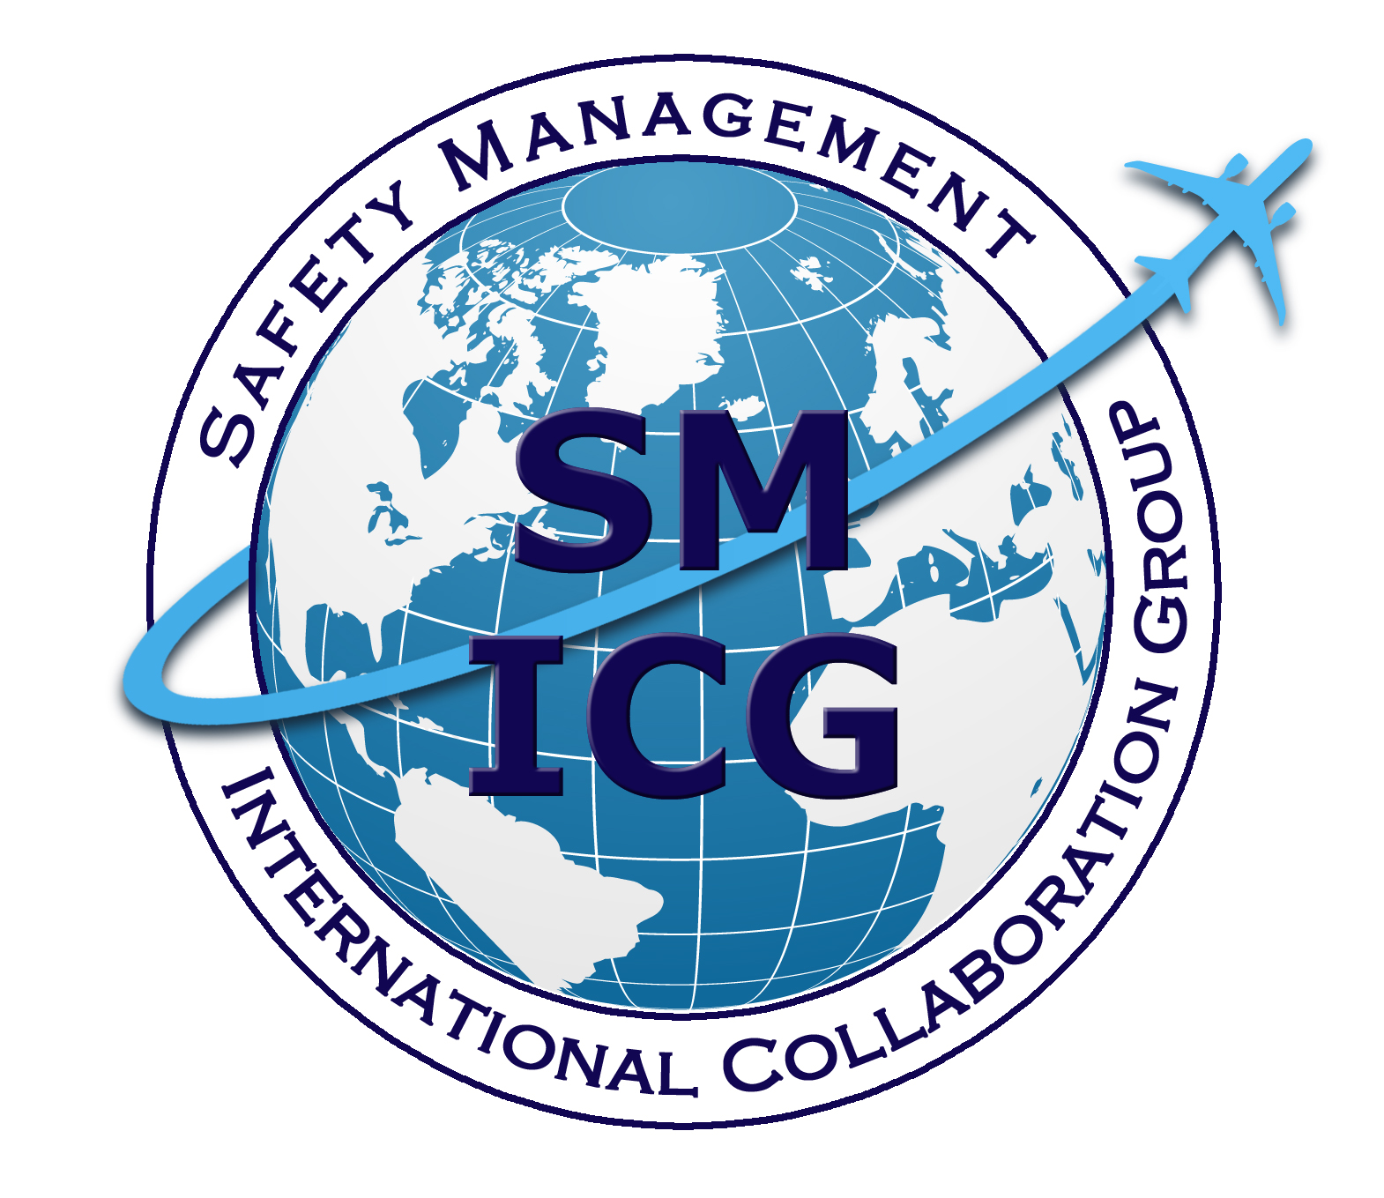

Transport Canada TP 13739 E (04/2001)

