**A Systems Approach to Measuring Safety Performance:**

**The Regulator Perspective**

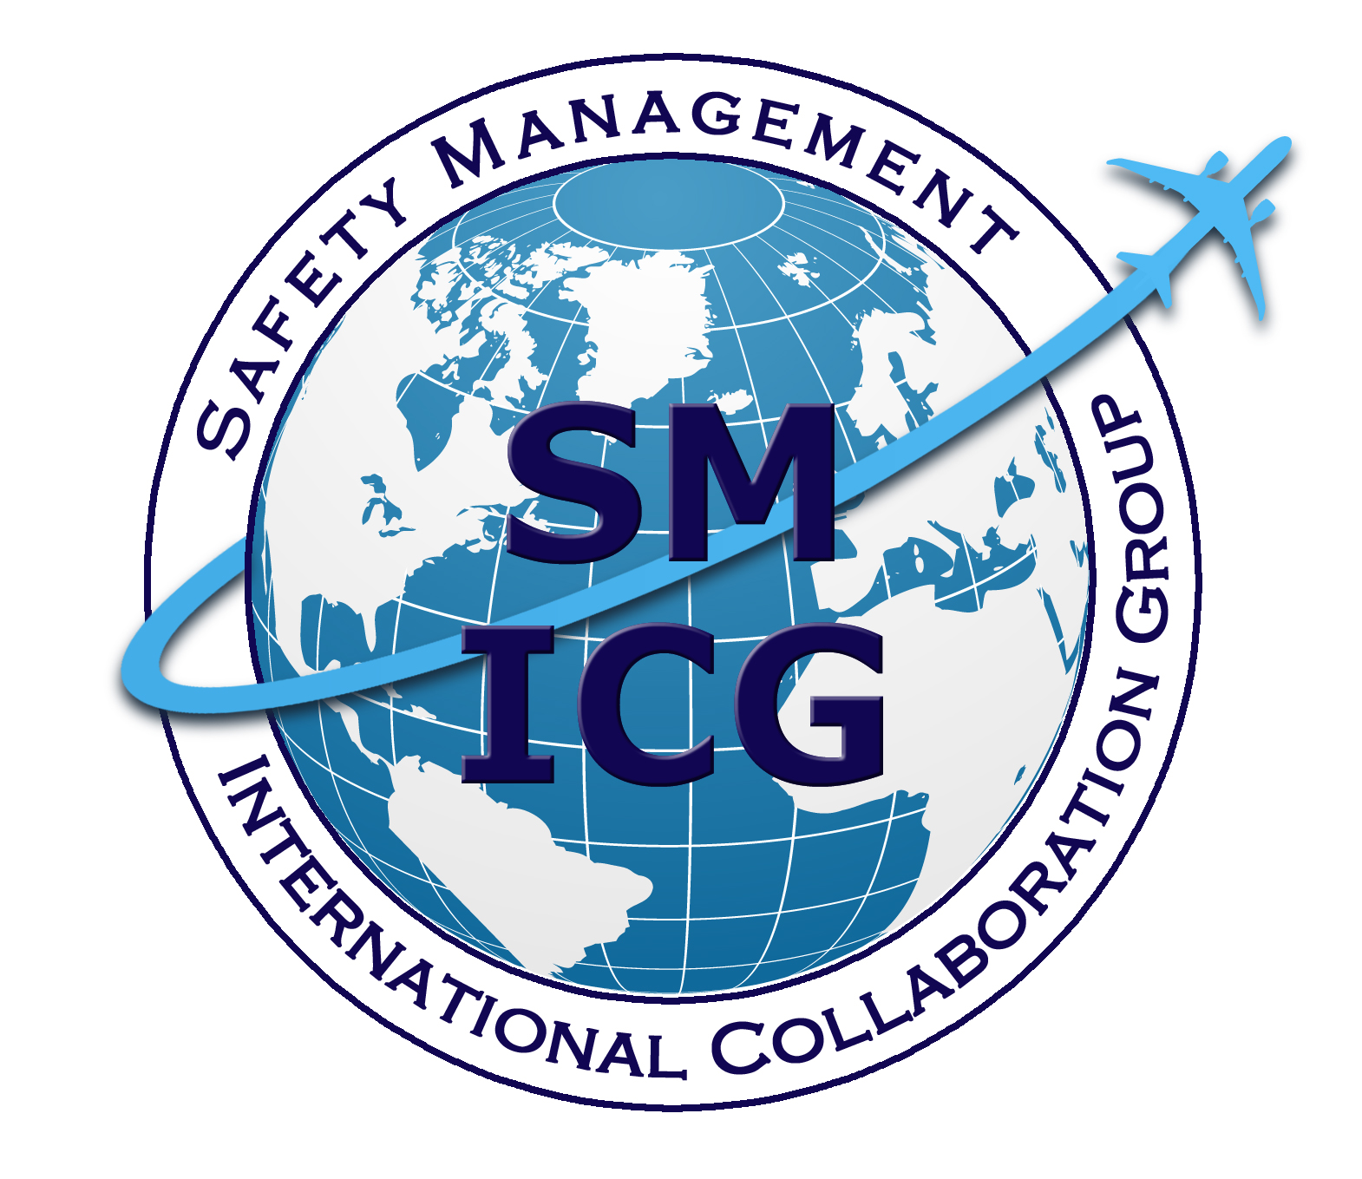

**January 27, 2014**

**Table of Contents**

Executive Summary ii

1. Introduction 1

1.1. Measuring Safety Performance 1

1.2. Terminology and Definitions 1

2. Aviation System Characteristics 1

2.1. The Civil Aviation System 1

2.2. The State Safety Programme (SSP) 1

2.2.1. Regulations as Risk Controls 1

2.2.2. Design Assurance 1

2.2.3. Performance Assurance 1

2.3. Types of Accident Causation and System Relationships 1

2.4. A Comprehensive Safety Management Approach 1

3. The Safety Performance Measurement System 1

3.1. Objectives 1

3.2. The Proposed Safety Performance Measurement Structure 1

3.2.1. Tier 1: Integrated Civil Aviation System 1

3.2.2. Tier 2: Service Provider Performance 1

3.2.3. Tier 3: Regulator Activities and Behaviors 1

3.3. Measurement Validity: A Combined View of the Correlations 1

Attachment 1: Safety Performance Measurement Guidance 1

Attachment 2: Sources of Safety Data and Safety Information 1

Acronyms 1

# Executive Summary

The purpose of measuring safety performance is to assess how well the aviation system is able to manage safety risks and where necessary to take action to build up and improve that capability.

Measuring the wrong aspects of safety performance at the wrong levels is akin to simply identifying the *disease* and ignoring the *symptoms*.

This is the basic premise of this paper. It presents a regulator-level view of where metrics need to be developed to tell us what the highest risks are and whether or not risks in the entire system —regulatory, service provider and inherent systemic risks— are being controlled effectively and in a predictive manner. The aviation system has many distinct but overlapping parts. Developing effective metrics requires an understanding of the system and the risks in individual processes in the areas of design, manufacturing, operations, airspace/air navigation, airworthiness, and training. Measurements must be able to identify existing and emerging risks in each of these overlapping parts and to monitor them to see whether regulatory actions have an effect on controlling or eliminating hazards.

For many years, regulators have used regulation, including certification and design assurance, to control risk. Surveillance and accident investigation support this regulation. However, regulation cannot control all risks; not all hazards can be identified by regulators. Further gains in safety must rely on structured, systematic hazard identification and control at the individual process level. Therefore, the role of the regulator must evolve from one of ensuring pure compliance, to prescriptive regulations, to one of monitoring its understanding of causes and contributing factors of failure in the aviation system.

This paper presents a model and its related framework for performance indicator development to guide regulators in identifying issues of common interest to the regulator and service provider as an integral part of their safety management.

The model is built on three tiers: regulator performance indicators (Tier 3), those of service providers   
(Tier 2), and safety outcome indicators (Tier 1). The objective of the model is to introduce a systems approach to measuring safety performance for effective safety management.

Each Tier’s characteristics are briefly described below.

|  |  |
| --- | --- |
| **Tier** | **Characteristics of Indicators** |
| **Tier 1 – The Integrated Civil Aviation System** | * Are event rates and the common causes that lead to high-level events (i.e. accidents, serious incidents); * Are statistically small in number compared to those in Tier 2 or 3; and * Reactive (learning from the event after it has happened). * Developing metrics for these requires determination of the causes and contributing factors in order to be able to design effective regulatory strategies to control hazards. |
| **Tier 2 –Service Provider Performance** | * Look at risk mitigation by service providers and regulators. * Are measures of outcomes other than accidents and serious incidents related to significant risk areas and of safety management system (SMS) performance of service providers. * Service provider performance will ultimately influence the high-level outcomes at Tier 1. |
| **Tier 3 – Regulator Performance (Activities)** | * Look at safety risk management by the regulator. * The metrics and indicators developed need to address specific risk areas identified through Tier 1 and Tier 2 indicators, as well as the regulator’s own safety risk management capability, including the effectiveness of the regulatory strategy. * The regulator must monitor how effectively it can control hazards and risks by influencing the behaviors of its service providers and of the overall system. |

.

# 

# 1. Introduction

## 1.1. Measuring Safety Performance

Measuring safety has typically been about measuring the absence of something —accidents. Accidents are the antithesis of safety, so measuring safety could require measuring accidents that did not occur. The vast majority of flights do not result in accidents, so it would be attractive to assume that safety is adequate, at least until an accident occurs. Clearly, this is not the type of measurement that enables management of safety.

The International Civil Aviation Organization (ICAO) (Annex 19, Chapter 1) provides a useful operational definition of safety, “The state in which risks associated with aviation activities are reduced and controlled to an acceptable level.” It follows that measures of safety should include the ability of the system or the service provider to effectively manage safety risks, which should be achieved through safety management processes. Safety performance is a construct that is used to measure the ability to effectively manage safety risk.

To gauge this ability it is necessary to have an accurate model of the system being measured, describing the system controls to enforce safety constraints in the form of regulations and standards as well as risk controls developed by the service provider, the system components and their interactions, the effects of those interactions on system safety, and the enablers of effective safety management. This is essential because the safety performance of individual system components does not guarantee the safety of the system as a whole. An accurate model is therefore necessary to establish appropriate measures for safety performance addressing both the system processes and output.

An effective measurement strategy should provide a set of measures reflecting system failures (e.g., accidents, incidents, regulatory violations) and indicators of the proper functioning of the system. Without measuring the right aspects of safety performance, at the right levels, measuring performance may simply capture outcomes. This may lead to inaccuracies, or worse, complacency that the system has reached a superior state of safety.

The systems of interest in aviation safety are socio-technical systems —systems composed of the interaction of human organizations and technology. Thus the behaviors of interest concern performance of both of these major system components. Components should also be considered in terms of their complexity and how closely they are coupled to, or interact with, other components to create unsafe situations.

Measures of safety performance should focus on how well the system is able to manage safety risks. An emphasis on system behaviors that can reduce the risk of adverse outcomes allows for meaningful safety performance metrics, that is, metrics to drive safety performance. To have any use in safety management, safety measures must reflect system behaviors related to safety risk control and contribute to decisions related to risk reduction.

The measurement system structure proposed in this document is based on three tiers of analysis that represent safety performance in terms of the activities of both States and service providers and the outcomes of those activities.

## 1.2. Terminology and Definitions

In this document, “service provider” is intended to cover providers of aviation services and products; “regulator” is used, in the broad sense, to cover all State functions and responsibilities relevant to the management of aviation safety.

The following terms and definitions are used in this document. When the common ICAO definition (as foreseen in draft Annex 19 or ICAO Document 9859) have not been retained, an alternative is proposed.

* **Design assurance**

The process to ensure that the service provider has incorporated appropriate risk controls into the design of its products, services and processes as a basis for the issue of, or changes to, certificates, authorizations, approvals, or acceptances on the part of the regulator.

*Synonyms: certification, changes to the certificate (European Union (EU))*

* **Performance assurance**

The process to ensure that the service provider maintains, throughout the provision of its products/services, the requirements of the certification, approval, acceptance, or authorization by the State, based on the State’s design assessment.

*Synonyms: continuing oversight (EU), surveillance (ICAO), continuing operational safety (United States)*

* **Safety performance**

**ICAO definition:** A State or a service provider’s safety achievement as defined by its safety performance targets and safety performance indicators.

* **Safety Performance Indicator (SPI)**

**ICAO definition:** A data-based safety parameter used for monitoring and assessing performance.

* **Safety performance target**

**ICAO definition:** The planned or intended objective for safety performance indicator(s) over a given period.

* **Safety Risk Management (SRM)**

A process to assess system design and verify that the system adequately controls risk.

A formal risk management process describes a system, identifies hazards, analyzes those hazards to identify and evaluate the associated risks, and establishes controls to manage those risks. This is one of the four components of SMS.

# 2. Aviation System Characteristics

## 2.1. The Civil Aviation System

Measures of the Civil Aviation System should be based upon an accurate model of the aviation system in the region and State, for which the authority has safety regulatory responsibility, that delineates the key components of the system, their key safety-related functions and objectives, and the interfaces between the components. The system cannot be thought of merely as a collection of components; any Civil Aviation System is a closely coupled system of systems, with many dynamic links and interdependencies between individuals, organizations, and technology. It is essential to base the measurement model on at least a rudimentary model of the State’s Civil Aviation System, including consideration of factors that are generic across the global Civil Aviation System, as well as those regional and local factors that are specific to each operating environment.

The best way to view the dynamics of the State’s Civil Aviation System, its components, interfaces (both internal and external), and risk situation is to view the complete life cycle, including design, manufacturing, ground and flight operation, maintenance, airport operations and airspace control. The life cycle includes initial issue of, changes to, and enforcement action on certificates, authorizations, approvals, or acceptances by the regulator.

To effectively measure safety performance in regards to the State Safety Programme (SSP) and the system of service providers, it will be important to understand the processes involved in delivery of aviation products and services, the sources of safety risk, and the controls necessary to provide the desired level of safety performance. This understanding will be essential to determining the information needs of the regulator.

The principal top-level components of the Civil Aviation System include:

* Design of aircraft and aircraft components and of changes to them;
* Manufacture of aircraft and aircraft components;
* Operation of aircraft;
* Airspace management and air navigation service provision, including maintenance of facilities;
* Operation and maintenance of aerodromes;
* Aircraft continued airworthiness and maintenance; and
* Fitness and competence of personnel.

Many interfaces and interdependencies exist among these components. Some processes are more tightly coupled than others. For example, design, manufacture, operations, and maintenance have the most direct effect on safe aircraft operations; other activities, such as initial flight training, contribute to a lesser extent.

The degree of coupling places demands upon the degree of integration required in terms of information flows, management structures and interfaces, and the type and degree of regulatory control that is appropriate. This also dictates that the processes of the regulator must be more highly integrated in these areas. The regulator organizations that are responsible for tightly coupled service provider functions must be able to exchange information freely, converse in detail, and, in some cases, engage in joint assessment and decision making. For example, reduction of runway excursions requires coordinated action in the area of air operations, air traffic management, and pilot training. Within each of these aviation system components, there are also diverse segments of aviation, such as commercial air carriers and general aviation as well as different characteristics of the individual organizations and other entities that operate in the system. These factors will also have a bearing on the selection of safety performance indicators and targeting of oversight under the SSP.

## 2.2. The State Safety Programme (SSP)

The SSP provides a structured mechanism for meeting State responsibilities for safety management using a systematic, risk- and performance-based approach. It provides an approach to system safety that stresses performance of safety critical processes in service provider activities and in State oversight functions. As such, it supplies a framework for safety decision making. An important aspect of the SSP is in defining the relationship between the State and the system of service providers through their safety management systems. This relationship is traditionally managed through the State’s oversight system.

The Eight Critical Elements of the State’s safety oversight system define the principal functional responsibilities of a State in design assurance and performance assurance of aviation service providers. The SSP provides a set of systematic processes for managing those responsibilities. To monitor and measure and, therefore, to manage the effective accomplishment of a State’s safety responsibilities, it will be beneficial to define these responsibilities in terms of processes within the SSP framework to deliver a more integrated, systematic approach to safety performance measurement.

### 2.2.1. Regulations as Risk Controls

Critical Element 2 (CE-2)[1], *Specific Operating Regulations*, requires States to promulgate regulations to address, at a minimum, national requirements emanating from the primary aviation legislation, that provide for standardized operational procedures, products, services, equipment, and infrastructures in conformance with the Standards and Recommended Practices (SARPs) contained in the Annexes to the Convention on International Civil Aviation.

Regulations are the first point of regulator influence on the State’s service providers. Regulations should be designed to control the system design, management practices, and organizational behavior of service providers. Regulators must apply safety risk management to the promulgation of regulations. The ability to produce effective regulations will depend on the regulator’s safety risk management capability being an integral part of its SSP.

One measurement of the overall effectiveness of a State’s body of regulations would be in the degree to which they cover key areas of risk and how completely and how well the regulations implement international standards. These are measures of the correlation between State activities (provision of risk controls and safety assurance) and service provider safety performance in terms of organizational behaviors.

### 2.2.2. Design Assurance

For regulations to be effectively employed, they need to be implemented in terms of the configuration of service provider systems, processes, programs, and procedures. Measures of the State’s safety performance must, therefore, include (but not be limited to) measures of how completely the State’s design assurance processes assure that regulations are translated into the operational processes of service providers.

Assurance that the service provider has incorporated appropriate risk controls into the design of its products, services, and processes is a basis for issue of certificates, authorizations, approvals, or acceptances on the part of the authority. CE-6, *Certification and Approval Obligations*, is described in terms of "documented processes and procedures to ensure that personnel and organizations performing an aviation activity meet the established requirements before they are allowed to exercise the privileges of a license, certificate, authorization and/or approval to conduct the relevant aviation activity." Under SSP and SMS concepts, the “established requirements” should include both compliance with applicable prescriptive regulations as well as meeting the performance expectations of the different components of the service provider’s SMS. This is particularly relevant in the area of product design, where appropriate risk controls are based on a review of analyses, tests, and inspections and where service providers are required to effectively demonstrate a safety risk management capability before the certificate may be issued. Design assurance therefore must consider the performance of service provider’s safety risk management processes.

Integration of certification processes into the safety management framework will provide a better framework for measurement and safety decision making for both authorities and service providers.

### 2.2.3. Performance Assurance

The goal of performance assurance is for the regulator to determine that service providers are effectively managing safety risks. This is mainly through determining if the risk controls implemented are controlling risks to acceptable levels.

CE- 7, *Surveillance Obligations*, is described as (ICAO Doc 9734, para. 3.1.2) “… processes such as inspections and audits to proactively ensure that service providers continue to meet the established requirements…”[2] The objective of CE-7 is part of the State’s safety assurance process.

Measures must be available both for use by the States in evaluating service provider performance in terms of processes and outcomes but also of the oversight activities themselves used to provide this assurance.

## 2.3. Types of Accident Causation and System Relationships

Once the relationships between the safety management systems of service providers and of States under their SSP are understood and modeled, it is next important to consider the relationships between patterns of accidents, accident causation, the types of countermeasures that may be applicable to broad types of causation, and, therefore the targets of outcome related measurements.[3]

Historical depictions of accident rates in nearly all regions and all segments of aviation (e.g., commercial, military, general aviation) show a period of steep decline for the early days of aviation through approximately the mid-1970s. From that time on, accident rates have been relatively flat or at least declining only marginally. In most occurrence rate vs. time relationships, such a set of conditions typically denotes a period dominated by common cause occurrences during the period of steep decline followed by a more level period of unique causes.

Common cause occurrences are those to which all or a large segment of the population of interest are exposed and for which there are equivalent or highly similar (and thus “common”) causes. Figure 1 depicts accident rates over time, dividing the trends shown (steep decline, slow decline, increase) into categories that are dependent on the organizational processes that are used to manage safety. The left part of the graph describes early-life failures, random failures, and wear-out failures for system components. In phase 1, prescriptive rules or regulations manage common cause failures, while in phase 2 more nuanced interventions via SMS, addressing organizational factors, processes and human performance make a slow improvement in an already much safer system. Phase 3 represents system failure to be avoided, whereby a lack of emphasis on the prescriptive, compliance-based regulations would mean that the gains made in phase 1 are lost.

PHASE 1: eliminating common causes

PHASE 3:

system failure or further improvement

?

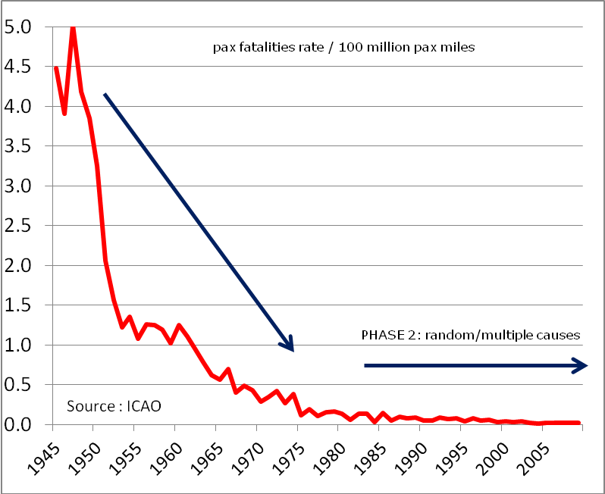

Figure 1. Accident Trends and Causes

These common causes are typically systemic in nature and, once addressed system wide, result in a new, lower baseline. A succession of improvements in technology, oversight/regulations, and training has brought about the improvements that we can see in the accident rate curves.

Common cause hazards are the ones that are most effectively addressed with equally broad and sometimes prescriptive countermeasures, such as upgrades in technology, training, or regulations. Once solutions are found, they are applied to the entire population, often resulting in a significant lowering of the accident rate. These types of countermeasures are the ones that make up the steep declining trend over the early part of the graph. At some point, though, most of the significant common causes are brought under control. To some extent this reflects that the limits of technology to affect further safety improvements. In terms of human factors, it also reflects a plateau with what can be done within human limitations. Further progress in identification and rectification of common causes will be slow and incremental at best.

The flattening of an occurrence curve is generally regarded as indicative of a situation more under the influence of random or unique causes. While small segments of the overall population may still have systemic causes, their influence on the overall population response is swamped by their uniqueness in the larger group.

After event rates plateau, causes of future events typically take on a more random characteristic, with causes becoming more unique to given operators, aircraft, events, regions, etc. Fewer accidents are related to broadly distributed exposure factors. Further gains in safety will depend on identification and control of hazards in a more nuanced fashion using strategies that help managers of individual aviation organizations identify and control hazards in the context of their unique configuration, business model, and type of operations.

This is where the SMS is important: Control of unique problems is best controlled by the processes incorporated in an SMS. The SMS requires a service provider to identify hazards in its systems and operational environment, assess these hazards for their degree of risk, and take action to control those that pose an unacceptable degree of potential harm. While the SMS processes may be a subject of regulations, the specific threats (“harms”) that are addressed through the SMS processes are not themselves a subject of prescriptive regulations. Therefore, measuring safety performance at the level of the service provider cannot be achieved solely using absolute levels of safety, or by compliance with prescriptive rules alone, which do not consider these specific, unique threats.

This is not to say that continued attention to maintenance, training, and compliance with prescriptive standards ceases to be important. To the contrary, these are the basis of maintaining the baseline of hard-won safety improvements. The right hand end of Figure 1 illustrates this point; relaxation of the controls that provided the safety improvements can easily reverse the process resulting in a return to original, higher event rates. Thus measurement of implementation and compliance with basic safety standards must be part of the safety management strategy.

These two situations also suggest that different safety management and regulatory strategies may be appropriate. Dr. Malcolm Sparrow, of Harvard University, uses a simple chart to show the relationship between “things that cause harm” and “things that are illegal.” Figure 2 is an adaptation of Dr. Sparrow’s principles in the form of a purely notional depiction, as system dynamics are not represented.

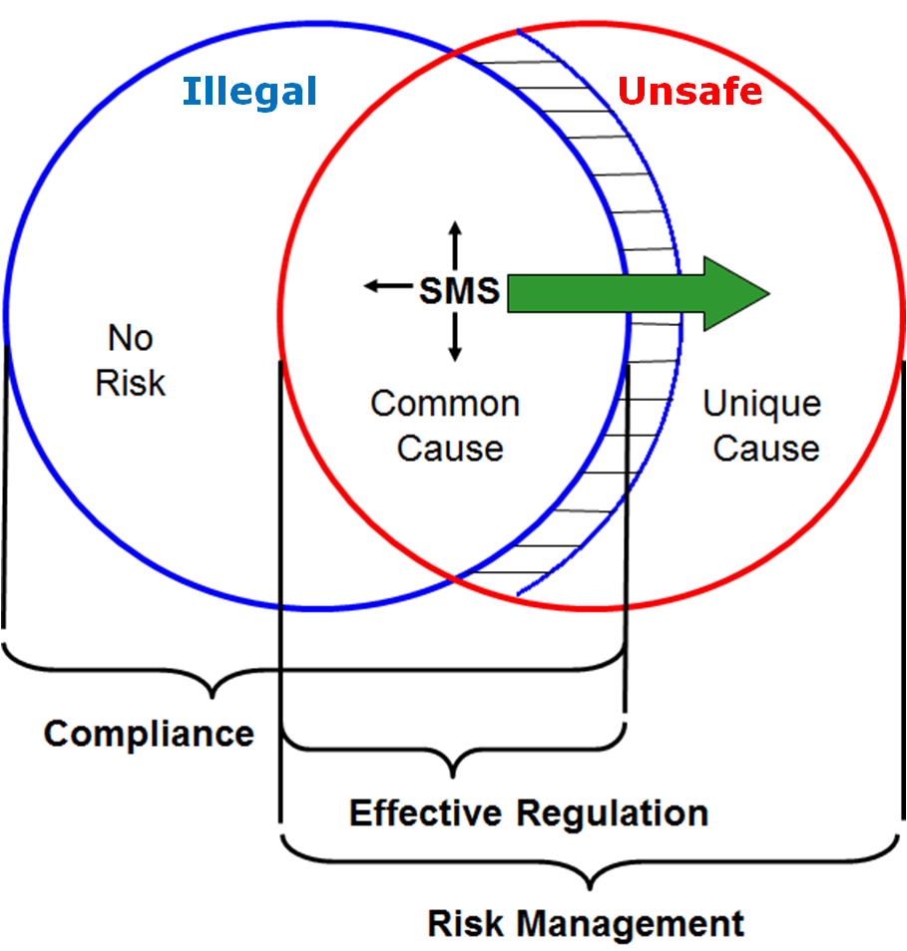

Figure 2. Relationship between Regulatory Requirements and Risk

Managing risk of all sources of harm would entail identification and management of all possible “unsafe” situations. While this is obviously not achievable, measurement of the effectiveness of risk management entails an assessment of how completely this is done. Though, there is typically an intersection between the two, the overlap is not total and not zero. The intersection between the two represents the set of situations in which hazards and threats are covered by regulations. These are the “common cause” hazards that were discussed above.

The area of “things that are illegal” but not harmful (the part of the left circle outside of the overlap area) represents ineffective regulations where compliance is not correlated with safety. This could be because the rules were inadequately developed to begin with, are obsolete, or were applied too broadly, to service provider groups that are not exposed to the hazard that the regulation addresses. This underlines the importance of performing period reviews of requirements and specific operating regulations, and implementing policies to ensure they remain relevant and appropriate to the service providers.

The area of “things that are harmful” but not illegal (the part of the right circle outside of the overlap area) represents those things that are either not appropriate for development of effective regulations for which, for whatever reason, the regulator has not implemented regulations. The area bounded by the blue line on the right outside of the area of overlap represents the latter condition, another form of regulatory ineffectiveness. This situation can exist when effective countermeasures are either outside of current technology or when the costs of implementing controls outweigh their benefits to society.

The problems that are in the intersecting area —those things that can cause harm and are the subject of regulations— are typically addressed through prescriptive, technical standards and regulations in the areas of technology, training, or task performance. Note that this is a subset of compliance and, if all rules appropriately addressed legitimate hazards, would represent the totality of compliance. As discussed above, this is not entirely achievable but regulators should strive to come as close to this objective as possible. Note that the SMS is placed in the overlap area between the circles.

Achieving *effective* compliance entails the use of a service provider’s safety risk management processes to tailor the method of compliance to its particular configuration and situation. Therefore, it could be claimed that there is a need for an SMS for all service providers that are the subject of prescriptive aviation safety regulations (safety risk management policies and procedures are required to effectively apply such regulations in the context of the service provider’s system).

## 2.4. A Comprehensive Safety Management Approach

Considering all the above, measuring safety performance should focus on those elements that are most important to managing safety, which are:

* The State’s ability through its oversight system to:
  + Identify new common cause threats ;
  + Respond to changes in the Civil Aviation System; and
  + Influence the behavior of the service provider to manage risk effectively.
* The State’s actions to provide risk controls on these common-cause threats and the effectiveness of those actions:
  + In the form of regulatory risk controls (CE-02); and
  + Through specific safety actions and safety initiatives, e.g., safety promotion, training, communication, toolkits and guidance material.
* The State’s actions to adapt the risk controls to ensure they remain effective considering the dynamics of the Civil Aviation System:
  + In the form of changes to the regulations or new regulations (CE-02);
  + Through specific safety actions and safety initiatives, e.g., safety promotion, training, communication; and
  + Through assuring the management of safety risks across organizational boundaries.
* The effectiveness of the State’s oversight system in relation to:
  + **Design Assurance:** Certification, licensing, approval, acceptance, and other authorizations (CE-06) of service providers, based upon a determination of their systems’ ability to control risk in their operations, in terms of SMS implementation.
  + **Performance Assurance:** Continuing oversight of service provider performance (CE-07), including effectiveness of SMS implementation, in terms of:
    - Compliance with regulations;
    - Ability to identify hazards (unique threats);
    - Effectiveness of service providers’ risk controls; and
    - Resolution of safety concerns (CE-08).

A measurement strategy for safety performance must take all of these elements into account. The State’s Safety Program and each service provider’s SMS provide the management framework for their respective safety management responsibilities. The application of both prescriptive standards and the development and implementation of performance-based risk controls —that can be in the form of regulatory action, oversight action or safety promotion action— depend on a structured, disciplined safety management framework. Due to the importance of context in systems and operational environments, the specific set of measures must be tailored to the unique needs of each region or State.

# 3. The Safety Performance Measurement System

## 3.1. Objectives

Safety performance measurement should be part of a process for continual improvement. Use of safety performance measurements enables adaptation of safety management processes and development of risk controls in a more proactive fashion. This means that the choice of indicators needs to consider the level of maturity of the system being measured, for both the State level and that of an individual service provider. A periodic review of the metrics being used is therefore necessary to ensure that the underlying model and indicators used remain valid, to take account of progress achieved and revise targets accordingly.

Measuring safety performance should enable the regulator to proactively influence the service provider’s management of safety. Accidents are frequently preceded by a breakdown of processes, especially between organizations. Through measuring the capability of organizations to manage safety, the regulator can identify systemic breakdowns and adapt the safety system before a bad outcome occurs.

The outcomes of safety performance measurement entail two potential determinations, 1) to assure that risk is being managed acceptably or 2) to adapt the aviation system through changes to safety objectives and/or safety requirements. Within item 2), changes can be made based on informed decision making that risk is currently being ineffectively controlled or that expected changes in the system will create hazards for which existing risk controls will not be effective. These determinations form the basis for adapting the system that manages safety. In essence, safety performance measurement must provide for informed decisions to continually improve system safety.

As an additional benefit, the act of modeling the Civil Aviation System, mapping hazards and risks, examining the process behind events and critical evaluation of existing data sources, safety performance measurement improves safety analysis capabilities and identifies data gaps. Where possible, these data gaps should be filled and may yield ancillary benefits, especially in the identification of emerging hazards in the Civil Aviation System.

## 3.2. The Proposed Safety Performance Measurement Structure

The measurement system structure is based on three tiers of analysis that represent the activities and performance of both the State and service providers in the Civil Aviation System. The matrix depicted in Figure 3 represents the general structure of the measurement system.

The matrix is composed of three tiers,[4] which describe the different levels of the system and provide an analysis framework to organize measures and interrelationships between the SSP, the service provider SMS, the Civil Aviation System, and the system of measures for these systems.

Indicators of performance should consist of both process and outcome measures. Process measures are measures of the functioning of key safety management processes, such as safety risk management and safety assurance on the part of both States and service providers. Outcome measures are measures of the direct results and ultimate benefits of the key safety management processes.

Validity of the measures at Tier 2 and Tier 3 is based upon the correlation with the next tier above it. For example, the validity of measures of oversight activities is based upon the relationship between the measured oversight activities and their influence on service provider behaviors and outcomes.

|  |  |  |  |  |
| --- | --- | --- | --- | --- |
|  | **A: Indicator Usage** | **B: Outcome Indicators** | **C: Process Indicators** | **D: Inter-tier Correlations** |
| **Tier 1**    INTEGRATED CIVIL AVIATION SYSTEM | Public information/ long term trending, identification of significant risk areas | (1) Accident rates,  Incident rates,  Fatalities (etc.)  (2) Breakdown of event rates for significant risk areas | ∑ Safety Management capability (effectiveness of):   * Identifying common cause hazards * Effectiveness of regulatory risk controls | N/A |
| **Tier 2**  SERVICE PROVIDER PERFORMANCE | Risk mitigation by service provider and regulator “most wanted issues” (SMS/SSP) | Per category of service provider:   * outcomes related to significant risk areas | SMS performance:   * SRM/compliance with regulatory specifications * Ability to identify unique cause threats * Effectiveness of risk control actions | Influence of service provider activities on safety outcomes |
| **Tier 3**  REGULATOR PERFORMANCE (ACTIVITIES) | Safety Risk Management  by regulator (SSP) | * Activities and initiatives to address specific risk areas * Effectiveness of risk controls (correlation with service provider behaviors and aggregate outcomes) * Effectiveness of risk control application (Oversight system performance – design assurance and performance assurance) | Safety risk management capability:   * Ability to identify common cause threats * Ability to develop risk controls * Ability to manage risk across organizational boundaries   Resource allocation:   * Efficiency of safety risk controls (cost/benefit) | Influence of regulator activities on service provider behaviors  Influence of regulator activities on safety outcomes |

Figure 3: Safety Performance Measurement Matrix

### 3.2.1. Tier 1: Integrated Civil Aviation System

Tier 1 SPIs include accident and serious/major incident data (damages, injuries, fatalities) and this data represents factual data which attracts a high public interest. These indicators are well suited for long term trending and identification of common factors applied to strategic planning. However, they should be used carefully for performance measurement of individual service providers or for short-term trending due to the low frequency of these events, and consequent large variability. Due to the low frequency, these are likely to work best at the aggregate level (e.g., regional or industry wide, with the aim to produce meaningful data).

***Outcomes***

Tier 1 outcome measures come in two varieties: overall event rates (e.g., accident rates, hull loss rates) and event rates related to significant risk areas (the Civil Aviation Authority of United Kingdom (UK CAA) *Significant Seven* list is an example). These event types are those associated with common cause hazards —those hazards to which all or large segments of the product/service provider community are exposed.

Examples of frequently used Tier 1 indicators include:

* Number of fatal accidents (in a 10 year period);
* Rate of fatal accidents in scheduled commercial air transport (CAT) operations;
* Rate of accidents in scheduled CAT operations;
* Rate of accidents in helicopter operations; and
* Number of fatalities in General Aviation operations (in a 5 year period).

***Processes***

Analysis at Tier 1 should also identify interventions that could be employed to reduce the risk of these events. These interventions become the focus of risk control processes, which are reflected in aggregate in the process column of Tier 1.

Identification of significant risk areas can take the form of analyses, such as those conducted by the Commercial Aviation Safety Team (CAST)/ European Commercial Aviation Safety Team (ECAST). Safety enhancement strategies developed by these groups are examples of processes related to the significant risk areas. An example of Tier 1 process measurement would be the degree to which these strategies are implemented. As in the identified significant risk areas and safety enhancement strategies, there should be a clear relationship between outcomes and processes.

Analysis of the scenarios in which accidents have occurred can be valuable to identify and validate factors associated with accident causation to ensure effective SRM. In order to be useful in identifying critical safety behaviors of aviation service providers, however, accident data must be obtained that goes beyond the surface level descriptions of human error and material failure. It must include analyses of organizational factors and other conditions that not only explain the accidents but identify the factors on which action can be taken. This will also require models of aviation operations that address these factors and that can be related to the models of the components of the Civil Aviation System discussed in the previous sections.

It is this analysis which is required to provide meaningful Tier 2 and 3 indicators associated with Tier 1.

### 3.2.2. Tier 2: Service Provider Performance

Tier 2 SPIs address the behavior of aviation service providers in order to identify key safety areas, which can be managed and addressed by safety actions. Tier 2 indicators should focus on (cf. § 2.4):

* The extent to which and how effectively service providers comply with the applicable regulations;
* How service providers respond to regulator controls for specific risks in the form of safety interventions and initiatives other than regulations; and
* How effectively service providers identify hazards and manage safety risks (SRM capability).

These behaviors should be assessed through the regulator’s design assurance and performance assurance processes, complemented with data through mandatory and voluntary occurrence reporting among other sources of safety data.

Further details on safety performance measurement for service providers may be found in the Safety Management International Collaboration Group (SM ICG) document, *Measuring Safety Performance: Guidelines for Service Providers*.

***Outcomes***

At Tier 2, a set of safety outcomes should be identified for monitoring. These should start with the significant risk areas identified for Tier 1, representing an association with common cause hazards. This set of outcomes should also include measures related to hazards that are unique to the category of service provider.

While desirable, it may not always be feasible to directly measure the significant risk areas that have been identified as common cause events. That is, if events such as controlled flight into terrain (CFIT) are identified as common cause events of interest at Tier 1, individual service providers may never suffer an actual event and, for those who do, they do not do so at a frequency that would be a valid measure of performance. The objective across the population of service providers is to reduce the risk of these events related to significant risk areas so as to reduce the aggregate occurrence rates.

In these cases, the measurement strategy should concentrate on related surrogate (or indirect) measures and associated process measures. An example of a surrogate measure could be tracking of low altitude or terrain alerts through a flight data analysis program. Associated process measures could include measures of implementation and management of such a program. Surrogate and process measures should be selected with caution to avoid the trap of defining measures that are easy to observe and thus quantify, but that do not accurately represent the outcomes of interest.

***Processes***

ICAO defines safety as, “the state in which the risk of harm to persons or property is reduced to and maintained at or below, an acceptable level through a continuing process of hazard identification and risk management.” Operationally defined, therefore, safety involves the processes of hazard identification and risk management. Simply put, safety can be measured in terms of how well risk is managed.[5] Measurement of safety management performance at Tier 2 would therefore be measured in terms of how well service providers perform those processes. As discussed before, compliance with regulations (the State’s specifications for control of hazards common to the service provider’s population) is part of the process of risk management. Therefore, measurement of compliance should also include measures of how well the service provider has used its SRM process to incorporate relevant regulations into its processes.

***Correlation***

To be considered valid, measures of service provider performance must be related (correlated) to Tier 1 outcome measures. Service provider behaviors are irrelevant to safety unless they can affect the safety “bottom line.” Because of this relationship and, as discussed above, the fact that safety outcomes in critical areas may not be measurable at the individual service provider level, it is important that aggregate outcome measures, selection of critical issues, and development of risk controls in terms of relevant processes be accomplished in a systematic fashion. Identification of relationships between outcomes and risk controls may only be feasible in the large sample scenario of Tier 1 such as the CAST/ECAST example. This is also an important consideration in selection of surrogate measures. They must clearly relate to the outcome measures of interest and they must be capable of explaining a significant portion of those outcomes.

### 3.2.3. Tier 3: Regulator Activities and Behaviors

Tier 3 indicators look at safety interventions and initiatives of the regulator under the SSP. These should include both process and outcome measures to gauge the safety interventions and initiatives of the regulator addressing the following areas (cf. § 2.4):

* The State’s ability to identify new common cause threats and monitor the effectiveness of existing controls in light of changes in the Civil Aviation System, through its oversight system;
* The State’s actions to provide risk controls on these threats and the effectiveness of those actions;
* The State’s actions to adapt the controls to ensure they remain effective considering the dynamics of the Civil Aviation System; and
* The effectiveness of the State’s oversight system (design assurance and performance assurance).

Effective regulator activities should motivate service provider behaviors that, in the aggregate, result in overall improvements in safety outcomes.

Tier 3 indicators will in many cases be linked directly to Tier 2 indicators as the latter are required to measure how effectively regulator activities and behaviors have addressed key safety issues identified. The ability to guide actions and influence future performance is an important characteristic of both Tier 2 and Tier 3 indicators.

***Outcomes***

At Tier 3, regulator activities must be based upon influencing the behaviors of service providers. Regulator action at level one considers the entire Civil Aviation System or major systemic components. Thus this responsibility entails management of common cause hazards. Accountability for identifying and designing risk controls for these common cause hazards rests primarily with the regulator. Effectiveness of the regulator’s accomplishment of this responsibility is, therefore, a matter of evaluating these functions.[6]

***Processes***

To be effective, regulatory risk controls must be effectively integrated into the operational systems of service providers. This requires not only action on the part of the service provider’s SRM functions but also oversight functions for the regulator to evaluate the *design* of the service provider’s systems. These assessments of service provider design activities should be the basis for certification, approval, acceptance or other authorizations.

Measures of regulator safety management performance should, therefore, include measures of how well the regulator is able to accomplish its design assurance (certification) functions. Validity of these measures should reflect the degree to which the regulator is able to influence the system and process design of service providers. Regulators’ design assessments should not be limited to risk controls based upon regulations but also include an assessment of how well the service provider has identified and controlled hazards that are unique to its systems and environment.[7]

As part of the performance assurance function, regulators must also assure *continuing operational safety* on the part of service providers. To do this, they must collect and analyze sufficient data, based on audits, inspections, occurrence data, direct observation as well as other data sources to make assessments of service provider performance.[8] Regulators must also take action on those areas of service provider performance that fail to control risk in their operations to an acceptable level.[9]

***Correlation***

Because the performance measures of regulator design and performance assurance processes must be based on their influence on service provider safety management objectives and performance, they must be correlated with the outcome and process measures of related service providers and of the strategic objectives at Tier 1.

## 3.3. Measurement Validity: A Combined View of the Correlations

Items in the 'Inter-Tier Correlations' column of Figure 3 refer to correlation between the items in Tier 3 with those in Tier 2 and subsequently with Tier 1. Correlations between measures and the constructs that they are intended to represent are measures of the validity of those measures. If we assume that service provider behaviors should produce desirable safety outcomes (e.g., reduction of accident risk) then valid measures of those behaviors should correlate with measures of safety outcomes. Likewise, the activities of regulatory authorities should influence the behaviors of service providers in ways that, in turn, result in desirable safety outcomes. Thus, measures of regulator performance and activities need to correlate with valid measures of service provider safety management effectiveness.

Well-functioning safety management processes, whether established under a service provider’s SMS or an SSP, require data to support analyses and assessments, as well as strategies to guarantee that these data possess certain attributes, such as data validity, completeness, timeliness, availability, and accuracy. Additionally, effective safety management is dependent on an effective data management process. Further guidance, including on data attributes and data management, may be found in the SM ICG document, *Risk Based Decision Making Principles*.[10]

At the outset, it may not be possible to identify quantitative measures at all levels that can be correlated statistically. This may be because of the limited understanding of process performance constructs in quantitative terms, inadequate modeling of the Civil Aviation System and its components, sparseness of or quality of data, or other reasons. This should not be cause to abandon the effort. Measures can be defined on either a rational or empirical basis. Those defined on a rational (theory-based) basis are those measures that "make sense" or, in statistical terms, have "face validity."

The strongest measures are those that are quantifiable, can be correlated between levels, and that can be explained in understandable, actionable terms. Progressive application of observation, analysis, and assessment will, over time, continuously improve our understanding of safety management processes and outcomes and enhance our ability to measure safety performance more effectively.

# Attachment 1: Safety Performance Measurement Guidance

The following tables provide further guidance on the three tiers within the safety performance measurement matrix, including examples of indicators.

| **Tier 1** | | |
| --- | --- | --- |
| **A** | Civil Aviation System Outcomes | These measure high level outcomes of the aviation system, as opposed to lower level direct outputs of individual elements of the system. |
| **B** | Safety Performance Indicators | High-severity occurrence data monitoring at sector level. Useful to standardize definitions where comparison with other states or regions would be beneficial. |
| **C** | Indicator usage | * Public opinion * Long-term trending * Setting objectives for further analysis (e.g., research) and action, * Measuring progress on a particular issue (e.g., specific segment of the aviation system/aircraft types) * Monitoring of performance at the level of different states or regions/ aviation segments (e.g., operators, manufacturers). Identify hazards in the Civil Aviation System or major system segments through analysis of accident scenarios (e.g., identify failure modes and effects analysis) * Results in mandatory actions, such as regulations * Information regarding inadequacy of service provider and regulator SRM * Information regarding ineffective risk controls of service provider and/or regulator   The low frequency of high-severity occurrences means that aggregation at a regional level may produce more meaningful analyses. |
| **D** | Relationship | There is relationship between Tier 1 and Tier 2, but this relationship can only be validated over a long period of time, due to the low frequency and variability of Tier 1 outcomes.  There is no direct link between Tier 1 and Tier 3, because the regulator can only take action on the service provider. |
| **E** | Resource Requirements | * Access to/implementation of systems and personnel to collect, interpret and analyze relevant data * Communication (media) |
| **F** | Additional Considerations | These indicators reflect the results of past action/ performance.  They are not primarily used for risk management (knowing what went wrong is not the same as knowing how to fix it).  The absence of occurrences may wrongly suggest a high level of safety. |
| **G** | Examples | * Rate of fatal accidents in scheduled passenger operations * Rate of fatal accidents in aerial work * Number of runway excursions/exposure * Number of fatalities in General Aviation operations |

| **Tier 2** | | |
| --- | --- | --- |
| **A** | Civil Aviation System Behaviors | These measure service provider behaviors in terms of compliance and SRM effectiveness. |
| **B** | Safety Performance Indicators | **OUTCOMES:**  General indicators will focus on potential accident outcomes within each sector and the factors that contribute to these risks.  Specific indicators will focus on lower level operational events to identify key safety areas that can be addressed through specific safety action of the regulator.  Indicators will be aggregated for the different components of the aviation system (operations, maintenance, air traffic management (ATM), aerodromes, etc.). Within each component, indicators may be further divided for specific types of service providers (e.g., for operations (OPS): CAT operators, General Aviation operators, private operators).  In the area of service provider risk controls, Tier 2 SPIs can be in the form of:   * Occurrence data based performance indicators: These take Tier 1 SPIs as a starting point (e.g., number of runway excursions/exposure), but are developed further down the causal chain from the main outcomes. This approach aims to identify the main accident/incident scenarios and related underlying causes to identify focus areas for risk controls. * Identification of hazards derived from potential accident scenarios or accident common themes for application to the development of safety performance indicators where no accident or major incident has ever happened. This method relies on proactive and predictive analysis and is indicative of a particularly mature safety management system. * Specific SRM effectiveness measures derived for the safety issues and hazards identified. These should include measures of lower level events that are direct outputs of individual elements of the system.   **PROCESSES:**  Process indicators will focus on SMS performance in terms of effective safety risk management, extent and effectiveness of compliance with regulatory specifications, and the service providers’ ability to identify unique cause threats. |
| **C** | Indicator Usage | Management of safety by the regulator and service providers:   * Evidence-based allocation of resources in terms of regulatory risk controls, design assurance, performance assurance, safety initiatives and safety promotion * Monitoring of compliance with regulations * Monitoring of SMS operation (capability and maturity of SMS related processes[11])   Once a key safety area has been identified using Tier 2 data, specific Tier 2 effectiveness indicators shall be defined to measure the effectiveness of the risk controls determined for a specific activity or group of service providers under consideration.  Depending on the data available and the maturity of SSP implementation, specific performance targets may then be derived considering the safety priorities identified and past performance. |
| **D** | Relationship | Effective management of risk lowers the incident and accident rates over time (Tier 1).  Operational events may be precursors to accident outcomes. |
| **E** | Resource Requirements | Regulator resources:   * Access to/implementation of systems to collect data   Industry resources:   * Compliance/implementation costs |
| **F** | Additional Considerations | Increasing reporting rates may be an indication of an improving reporting culture.  Defining Tier 2 indicators for lower level operational events should take into account possible unintended effects. Service providers may tend to take higher risks to avoid certain outcomes that they know are measured (e.g., measuring the number of go-arounds instead of measuring un-stabilized approaches).  Incident data:  For incident data to be used in safety performance measurement they must be correlated with the causal chain leading to fatal accidents. It is now widely accepted that many types of typical low-level events may not adequately predict the occurrence of fatal accidents. Root causes of minor incidents may not correlate highly with causes of more serious events unless underlying causes are analyzed thoroughly. This also underscores the need to use additional incident data from sources such as employee reporting and flight data analysis programs. |
| **G** | Examples | **OUTCOMES:**   * Operations:   + Number of Traffic Alert and Collision Avoidance System (TCAS) resolution advisories   + Number of Ground Proximity Warning System (GPWS) and Enhanced Ground Proximity Warning System (EGPWS) warnings per number of take-offs * Maintenance:   + In Flight Shut Down (IFSD) per number of flight hours (FH)   + In Flight Turn Backs (IFTB) and deviations per number of take-offs   + Rejected take-offs per number of take-offs due to technical issues * ATM/Air Navigation Services (ANS):   + Number of level busts/exposure   + TCAS Risk Avoidance (RA) (with and without loss of separation)   + Minimum separation infringement   + Inappropriate separation (airspace in which separation minima is not applicable)   + Aircraft deviation from air traffic control (ATC) clearance   + Airspace infringement   + Aircraft deviation from ATM procedures   + Near Controlled Flight Into Terrain (CFIT) IFSD   + Runway incursion where no avoiding action was necessary   + Runway incursion where avoiding action was necessary * Airports:   + Fire Extinguishing Services (ICAO Airport Fire Fighting Categories) decrease in value (number decrease in hours/number of airport annual operating hours)   + Runway incursions per n operations   + Notified platform safety rules violations per n operations notified bird strikes per n operations.   **PROCESSES:**  Compliance (aggregate numbers):   * Number of non-compliances per oversight planning cycle * Ratio of significant non-compliances * Number and type of enforcement actions * Number of certificates suspended per oversight planning cycle * Average lead time for completion of corrective actions * Ratio of non-compliances identified by the regulator not previously identified by the service provider through the internal audit function   SMS Effectiveness (aggregate numbers):   * Maturity index (level 1, 2, 3) * Turn-over rate of key safety personnel * Number of risk controls monitored and validated per month/quarter * Percentage of overall budget allocated to new risk controls * Percentage of hazards tracked through to resolution |

| **Tier 3** | | |
| --- | --- | --- |
| **A** | Aviation System Behaviors | Tier 3 indicators look at safety interventions and initiatives of the regulator under the SSP. These are process and outcome measures to gauge the safety interventions and initiatives of the regulator. |
| **B** | Safety Performance Indicators | The State should define how to aggregate indicators (e.g., globally/per component/per segment within a specific segment of the Civil Aviation System). The higher the rate of aggregation, the more difficult it may be to target actions.  Example 1:   * Component: Operators * Segments: commercial air transport, business aviation, international general aviation, other general aviation, aerial work   Example 2:   * Component: manufacturers * Segments: aircraft, engine, propeller, parts and appliances   **OUTCOMES:**  Tier 3 outcome indicators will address activities and initiatives to address specific risk areas:   * The effectiveness of risk controls for new common cause threats identified (correlation with service provider behaviors and aggregate outcomes):   + In the form of effective regulations, and   + Through specific actions and safety initiatives, (e.g., safety promotion, training, communication). * The effectiveness of the State’s oversight system (design assurance and performance assurance).   **PROCESSES:**  Tier 3 process indicators will address:   * The State’s ability to identify new common cause threats; * The State’s ability to monitor the effectiveness of existing controls in light of changes in the Civil Aviation System; through its oversight system; and * The State’s actions to review and adapt the controls to ensure they remain effective considering the dynamics of the Civil Aviation System. |
| **C** | Indicator Usage | To monitor the regulator’s efforts to implement and maintain the SSP.  Tier 3 measures shall support evidence based decision making and resource allocation by the regulator. They may also be used for communication purposes and benchmarking with other States. |
| **D** | Relationship | The activities of the regulator directly influence service providers.  Example:  Data protection encourages sharing of data which promotes hazard identification and risk analysis that will have an impact on Tier 2 and ultimately on Tier 1 as well.  The effectiveness of safety risk management by the regulator is monitored at Tier 2. Therefore, for each safety action to address a key safety area one or more Tier 2 indicators need to be defined.  Example 1:   * Safety action: communication on “just culture” * Corresponding Tier 2 “implementation” indicator: increase in number of mandatory and voluntary occurrence reports received   Example 2:   * Key safety issue: runway incursions * Tier 2 indicator: rate of runway incursions * Corresponding outcome (Tier 1 indicator): aircraft collision on ground (not directly relevant to managing the risk identified)   Based on the regulator’s risk assessment of these occurrences, including an identification of triggering events and contributing factors the regulator initiated specific mitigation action addressed to ATC. A Tier 3 indicator is set for measuring the regulator’s activity (and resource allocation) as related to this action. The corresponding Tier 2 effectiveness indicator is defined as “proportion of runway incursions that include ATC as a risk factor” (either related to avoidance or related to recovery). Monitoring this indicator will inform the regulator of the effectiveness of the mitigation action that has been implemented. |
| **E** | Resource Requirements | Regulator resources:   * Access to/ implementation of systems to collect data * Expenditure for promulgation of regulations * Expenditure for design assurance and performance assurance * Expenditure for specific safety actions (safety promotion, training, risk reduction programs) |
| **F** | Additional Considerations | There may be Tier 3 indicators in areas where currently no acute safety issue has been identified, because mitigation is effective. In such cases, the regulator may still chose to develop an indicator in order to ensure that the measure continues to perform effectively.  Example:   * Number of random inspections |
| **G** | Examples | **OUTCOMES:**  Design and performance assurance:   * Average processing time for new applications/type of approved organizations (weighted by number of inspectors) * Number of scheduled audits/type of approved organization per planning period * Number of unannounced inspections/type of approved organization per planning period * Number of SMS assessments/type of approved organization per planning period * Number of enforcement actions/type of approved organization per planning period   Risk reduction programs:   * Effectiveness of runway safety initiatives * Effectiveness of ground handling safety initiatives   **PROCESSES:**  Systemic or common cause hazards:   * Rate of transposition of international standards, including on SMS * Rate of amendment of airworthiness regulations to keep pace with technological evolutions * Implementation support: number of workshops per aviation segment   Protection of data:   * Existence of regulations on data protection * Successful lawsuits to enforce data protection   Safety promotion:   * Number of safety bulletins issued per year/aviation segment * Harmonization with guidance material of other regulators |

# Attachment 2: Sources of Safety Data and Safety Information

Regulators have at their disposal different sources of safety information to help them define and select SPIs. This document describes some of the sources that regulators usually have available and their possible advantages or disadvantages.

Access to safety information and its protection vary significantly in different States. This guidance is intended to be adapted to the reality of each State’s domestic legislation.

The first caution on access to safety information sources is that there is a natural tendency to use information at hand without trying to obtain the kind of information needed to assess certain safety risks or safety performance at the level of the regulator. In other words, instead of asking what can be measured with the information at hand, the regulator should identify what it intends to measure or evaluate, and according to the answer to this question it should identify the sources of safety information that could be useful. Some sources will already be available, while others may require additional efforts to collect data. However, in the exercise of trying to identify adequate safety information sources some imagination when a particular type of data is unavailable, in order to identify some other safety information sources that are closely related to the question at hand.

It is also imperative that regulators encourage their industry to report safety events and safety information; to that end, it is key to provide feedback to those reporting as a way to show that their efforts are far from vain.

Regulators should avoid being too “greedy” in the search for safety data and information, as this may result in having a large volume of information and being unable to process it. In most cases, the following safety information sources easily available to the regulator may be used:

* **Safety investigations:**

The civil aviation safety system is partially based on feedback and lessons learned from accidents and incidents. According to the international SARPS set out in Annex 13 to the Chicago Convention, the investigation of accidents and serious incidents is to be conducted under the responsibility of the State where the accident or serious incident occurs. This type of reactive information is essential to review, in order to disseminate lessons learned.

* **Occurrence reporting; mandatory and voluntary:**

According to the international SARPS set out in Annex 19 to the Chicago Convention, States shall establish a mandatory incident reporting system to facilitate collection of information on actual or potential safety deficiencies, and States shall also establish a voluntary incident reporting system to facilitate collection of information on actual or potential safety deficiencies that may not be captured by the mandatory incident reporting system.

The kind of safety information captured by the occurrence reporting systems refers to subjective information mainly provided by service providers and aeronautical personnel. A mature occurrence reporting system is essential to capture both reactive and proactive safety information necessary to identify safety hazards within the Civil Aviation System. When using such information, regulators should be aware of possible bias due to different degrees of reporting culture maturity in different components or segments of the Civil Aviation System. To evaluate risks in areas where underreporting is a problem it may be necessary to obtain objective information from other sources.

* **Information generated by the regulator itself :**

As part of their safety oversight system, regulators shall use processes for design and performance assurance, entailing inspections and audits, on a continuous basis. The results of these audits and inspections represent valuable information available to the regulator. This information must be structured in a way that it can be easily analyzed. Moreover, considering that safety involves several interrelated aviation systems components and subsystems, it is also important to analyze such data from a holistic perspective.

* **Information generated by other regulators:**

According to the Chicago Convention, States can conduct inspections and audits of aircraft flying to or from an airport in their territory. The results of such inspections and audits conducted by other Civil Aviation Authorities constitute one important element of safety information available to the regulator.

* **Exchange of safety information programs with the industry:**

Some regulators have established safety information exchange programs with the industry (airlines, manufacturers, air navigation service providers, airports, aerial work companies, etc.). These programs seek to collect objective information that is relevant to measure the safety “temperature” of the State’s aviation system.

For the implementation of this type of information exchange programs, it is important to agree with the industry on the type of information that should be exchanged. These programs can be established on a voluntary or mandatory basis. Contributors may be offered in return the possibility to compare their safety performance data with those from the rest of the industry, i.e. regulators can provide access to previously de-identified and aggregated information for a particular industry segment).

# Acronyms

ANS Air Navigation Services

ATC Air Traffic Control

ATM Air Traffic Management

CAST Commercial Aviation Safety Team (US)

CAT Commercial Air Transport

CE Critical Element

CFIT Controlled Flight Into Terrain

EASA European Aviation Safety Agency

ECAST European Commercial Aviation Safety Team

EGPWS Enhanced Ground Proximity Warning System

EU European Union

GPWS Ground Proximity Warning System

ICAO International Civil Aviation Organization

IFSD In Flight Shut Down

IFTB In Flight Turn Backs

SARPS Standards and Recommended Practices

SM ICG Safety Management International Collaboration Group

SMS Safety Management System

SPI Safety Performance Indicator

SRM Safety Risk Management

SSP State Safety Programme

TCAS Traffic Alert and Collision Avoidance System

UK CAA Civil Aviation Authority of United Kingdom

This paper was prepared by the Safety Management International Collaboration Group (SM ICG). The purpose of the SM ICG is to promote a common understanding of Safety Management System (SMS)/State Safety Program (SSP) principles and requirements, facilitating their application across the international aviation community.

The current core membership of the SM ICG includes the Aviation Safety and Security Agency (AESA) of Spain, the National Civil Aviation Agency (ANAC) of Brazil, the Civil Aviation Authority of the Netherlands (CAA NL), the Civil Aviation Authority of New Zealand (CAA NZ), the Civil Aviation Safety Authority (CASA) of Australia, the Direction Générale de l'Aviation Civile (DGAC) in France, the European Aviation Safety Agency (EASA), the Federal Office of Civil Aviation (FOCA) of Switzerland, Japan Civil Aviation Bureau (JCAB), the United States Federal Aviation Administration (FAA) Aviation Safety Organization, Transport Canada Civil Aviation (TCCA) and the Civil Aviation Authority of United Kingdom (UK CAA). Additionally, the International Civil Aviation Organization (ICAO) is an observer to this group.

Members of the SM ICG:

* Collaborate on common SMS/SSP topics of interest
* Share lessons learned
* Encourage the progression of a harmonized SMS
* Share products with the aviation community
* Collaborate with international organizations such as ICAO and civil aviation authorities that have implemented or are implementing SMS

For further information regarding the SM ICG please contact:

Regine Hamelijnck Jacqueline Booth Amer M. Younossi

EASA TCCA FAA, Aviation Safety

+49 221 8999 1000 (613) 952-7974 (202) 267-5164

[regine.hamelijnck@easa.europa.eu](mailto:regine.hamelijnck@easa.europa.eu) [jacqueline.booth@tc.gc.ca](mailto:jacqueline.booth@tc.gc.ca) [Amer.M.Younossi@faa.gov](mailto:Amer.M.Younossi@faa.gov)

Carlos Eduardo Pellegrino Ian Banks

ANAC CASA

+55 213 5015 147 +61 2 6217 1513

[carlos.pellegrino@anac.gov.br](mailto:carlos.pellegrino@anac.gov.br) [ian.banks@casa.gov.au](mailto:ian.banks@casa.gov.au)

SM ICG products can be found on SKYbrary at:

[http://www.skybrary.aero/index.php/Safety_Management_International_Collaboration_Group (SM_ICG)](http://www.skybrary.aero/index.php/Safety_Management_International_Collaboration_Group_(SM_ICG))

1. Cf. ICAO Doc 9734 – In ICAO Annex 19 no reference is made to CE, however, the details of each CE are now included with Appendix I ‘State Safety Oversight System’, having the status of an ICAO Standard.
2. ICAO Doc 9734, para. 3.1.2.
3. An example is the UK CAA *Significant Seven* list: Loss of Control, Runway Overrun or Excursion, Controlled Flight into Terrain, Runway Incursion and Ground Collision, Airborne Conflict, Ground Handling Operations Safety Team, and Airborne and Post-Crash Fire.
4. The three tiers were adapted from the work of Dr. Malcolm Sparrow in 2000, Harvard University.
5. This simplified operational definition presupposes that hazard identification is a prerequisite to managing the associated risk.
6. This would also measure critical element of oversight number two (CE-2).
7. This would also be a measure of critical element of oversight number six (CE-6). Such a measure should be based on the regulator’s assessment of the service provider’s effective use of their SRM process in order to assure that the designs of their systems effectively control hazards as intended in regulations as well as any hazards unique to the service provider.
8. This would also measure critical element of oversight number seven (CE-7).
9. This would also measure critical element of oversight number eight (CE-8).
10. <http://www.skybrary.aero/index.php/Risk_Based_Decision_Making_Principles>
11. Reference “SMS Evaluation Tool” <http://www.skybrary.aero/bookshelf/books/1774.pdf>