
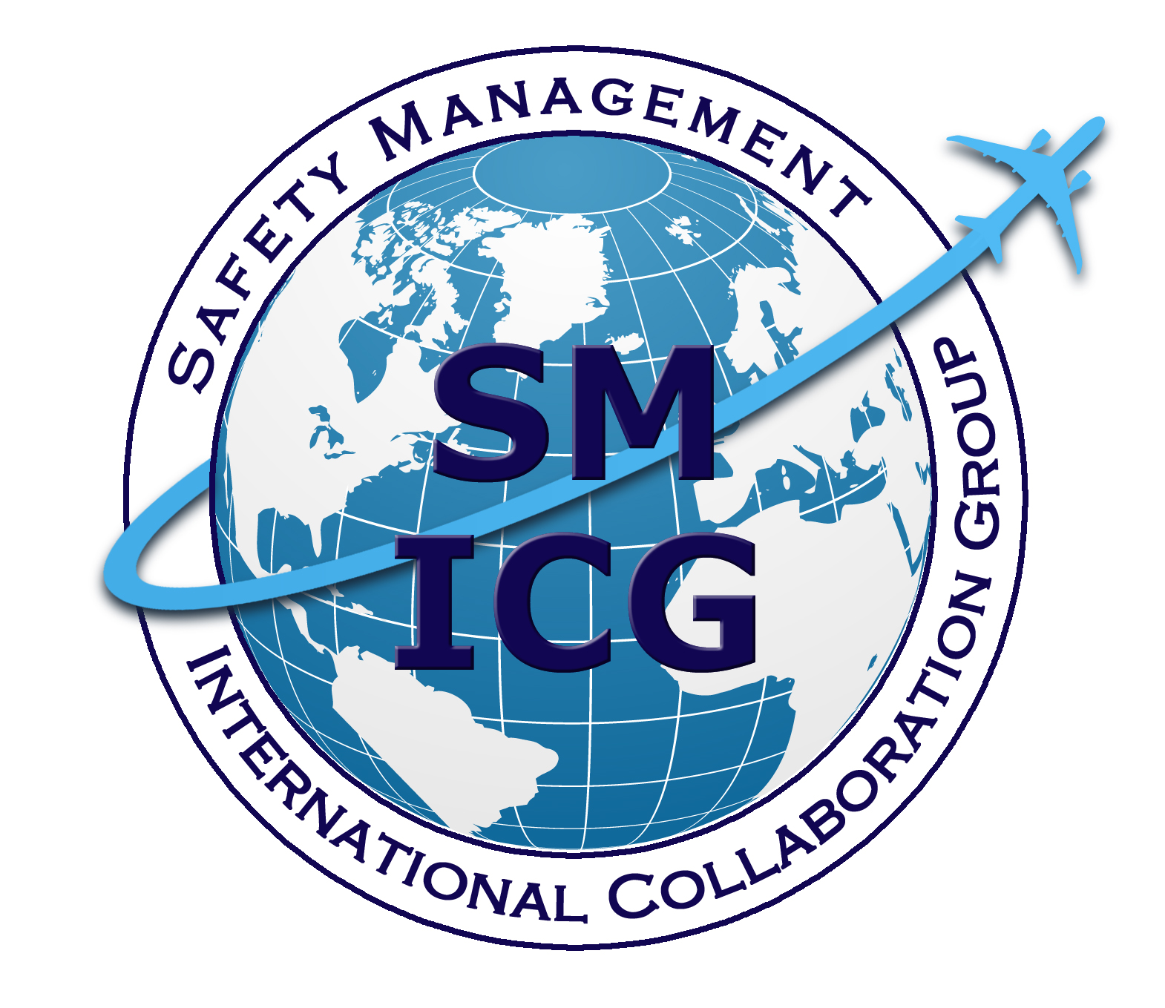
How to Support a Successful State Safety Programme (SSP) and
Safety Management System (SMS)
Implementation

Recommendations for Regulators
May 2016
This paper was prepared by the Safety Management International Collaboration Group (SM ICG). The purpose of the SM ICG is to promote a common understanding of Safety Management System (SMS)/State Safety Program (SSP) principles and requirements, facilitating their application across the international aviation community. In this document, the term “organization” refers to a product or service provider, operator, business, and company, as well as aviation industry organizations; and the term “authority” refers to the regulator authority, Civil Aviation Authority (CAA), National Aviation Authority (NAA), and any other relevant regulatory body, government agency, or entity with oversight responsibility.

The current core membership of the SM ICG includes the Aviation Safety and Security Agency (AESA) of Spain, the National Civil Aviation Agency (ANAC) of Brazil, the Civil Aviation Authority of the Netherlands (CAA NL), the Civil Aviation Authority of New Zealand, the Civil Aviation Authority of Singapore (CAAS), the Civil Aviation Safety Authority (CASA) of Australia, the Direction Générale de l'Aviation Civile (DGAC) in France, the Ente Nazionale per l'Aviazione Civile (ENAC) in Italy, the European Aviation Safety Agency (EASA), the Federal Office of Civil Aviation (FOCA) of Switzerland, the Finnish Transport Safety Agency (Trafi), the Irish Aviation Authority (IAA), Japan Civil Aviation Bureau (JCAB), the United States Federal Aviation Administration (FAA) Aviation Safety Organization, Transport Canada Civil Aviation (TCCA) and the Civil Aviation Authority of United Kingdom (UK CAA). Additionally, the Civil Aviation Department of Hong Kong (CAD HK), the International Civil Aviation Organization (ICAO), and the United Arab Emirates General Civil Aviation Authority (UAE GCAA) are observers to this group.

Members of the SM ICG:
- Collaborate on common SMS/SSP topics of interest
- Share lessons learned
- Encourage the progression of a harmonized SMS/SSP
- Share products with the aviation community
- Collaborate with international organizations such as ICAO and authorities that have implemented or are implementing SMS and SSP

For further information regarding the SM ICG, please contact:
Regine Hamelijnck Jacqueline Booth Amer M. Younossi
EASA TCCA FAA, Aviation Safety
+49 221 8999 000 (613) 952-7974 (202) 267-5164
regine.hamelijnck@easa.europa.eu jacqueline.booth@tc.gc.ca Amer.M.Younossi@faa.gov

Igor Penna Mike Hutchinson
ANAC CASA
+55 613 3144 826 +03 9518 2774
igor.penna@anac.gov.br Mike.Hutchinson@casa.gov.au

SM ICG products can be found on SKYbrary at: http://bit.ly/SMICG

To obtain an editable version of this document, contact smicg.share@gmail.com.
The intent of this document is to provide best practices concerning the internal and external prerequisites for implementing and promoting an effective State Safety Programme (SSP) and safety management systems (SMS). While the list is not exhaustive, it does cover many of the key areas that might require attention and review, giving readers guidance on where to begin. For ease of reference, it has been structured in line with the International Civil Aviation Organization (ICAO) SSP Framework proposed in Annex 19.

This document builds on the experience of the members of the Safety Management International Collaboration Group (SM ICG) with respect to the implementation of an SSP and SMS in civil aviation organizations.

The implementation of SSP and SMS is not simply a regulatory drafting exercise; it will most likely involve major changes in the way you, the authority, conduct and organize your business. Compliance to all applicable ICAO Standards and Recommended Practices (SARPs) remains the foundation on which State safety programs are established. The concepts of performance or risk management in Annex 19 do not absolve the States from complying with the existing provisions in other Annexes, which remain fundamental to aviation safety.

Accordingly, prior to implementation, States must have basic capabilities, which include the ability and capacity to:
- Implement regulations that address ICAO Annexes;
- Oversee their aviation organizations through a consistent and adequate set of processes and programs;
- Perform effective accident and incident investigations; and
- Maintain a qualified and adequate workforce.

Recommendations for Authorities

1.1 — State safety legislative framework
- It is important to recognize that an SSP is an activity and not just a document, although a description of the SSP may be developed as a high-level summary document of the SSP activities.
- Consult with your organizations from the beginning of the drafting process on the regulations and standards that relate to implementing an SMS. Continue to consult to ensure organizations’ practices are captured and that they understand what needs to be changed.
- Continually improve the regulatory framework. SMS is a dynamic system, and as it evolves, there are learning opportunities. These experiences should be captured in revised regulations, with the goal of creating a comprehensive set of requirements that offer an appropriate balance of both prescriptive and performance-based regulations.
- Do not regulate through guidance material, but it is important to have useful guidance material to help both organizations and authorities understand the intent and application of the regulation.
- Consider the balance between SMS regulations and supporting means of compliance and guidance material.
- Review what you have in the existing regulatory structure; do not reinvent the wheel. This will promote increased and swifter acceptance of SMS.
- The regulations do not have to mirror the ICAO framework word for word; the regulations should, however, address all safety objectives entailed by the requirements contained in the Annexes. The language should reflect the national culture and the aviation industry.
- Wherever possible, develop generic safety management regulations. In this way, you will avoid having to change multiple regulations. However, specific guidance material may be needed based on type of operations, size, and complexity.
- Provide a flexible framework that is objective or performance based rather than prescriptive. In certain circumstances, the possibility of using alternative means of compliance should be acceptable and available to the organization.
- Define a process to assess alternative means of compliance proposed by the organization and a means to publish it to provide transparency.
- Establish a requirement for organizations to nominate an Accountable Executive or manager as well as for defined safety responsibilities for key personnel within the organization.
- Train your key personnel in SSP and SMS concepts before putting SMS regulations in place.
- Regulations should recognize interdependencies between all disciplines of civil aviation.
- Periodically review your internal policies to determine if they promote or set up barriers to an effective SMS.
- Develop procedures that allow for a phased implementation of an SMS. Remember: an SMS cannot be built overnight. A series of activities must occur before an SMS can be operational and effective. This will require you to define expectations for each phase of implementation.
- The regulations must allow for SMS implementation in both existing organizations (who will be transitioning to an SMS) and new applicants (who may be starting an SMS from nothing).
- The number of phases should be appropriate to your ability to provide adequate surveillance and your confidence in the organization’s ability to manage the implementation process.
- SMS should be considered as part of the normal certification or approval process for new entrants. Consider extending the assessment period to allow for effective implementation of all SMS-related systems.
- The benefits of a phased approach to implementation and oversight are that:
  - It provides a manageable series of steps for organizations to follow with clearly defined expectations for each phase;
  - It provides for continuous improvement through “lessons learned”; and
  - It allows for an effective implementation of SMS.
- Multiple implementation phases are typically identified; the number of phases will depend on the type of organization. Things to consider are the number of certificates or the type of certificate held, the size and complexity of the organization, the type of operation (e.g., air operator's certificate (AOC), manufacturer). Each phase involves the demonstration that specific SMS processes are in place or are effective.
- Depending on the approach chosen, you may require immediate compliance with all key processes, in which case the effectiveness of the processes must be demonstrated. However, it is unrealistic to expect an organization to have an effective SMS from its first day of implementation. Another approach is to phase in the implementation of the SMS processes and determine their effectiveness as each phase is completed.
- Coordinate other regulatory requirements within the State to avoid overlaps. This includes specific requirements that may be found in multiple areas of the aviation safety regulations (e.g., emergency response plans, quality assurance, risk management) and other existing requirements outside of aviation safety regulations (e.g., occupational health and safety, environmental management).
- Review international regulations for conflicts, compliance, and differences.

1.2 — State safety responsibilities and accountabilities
- The Accountable Executive for the SSP is not always easy to identify. The person with the appropriate authority within the State may be in an agency other than the authority.
- The Accountable Executive should reside in the highest position within a State with the authority to direct resources as required to achieve the safety objectives of the State. The Director General of Civil Aviation may be that person.
- For larger State organizations, SSP gap analyses may be required within individual functional areas, as different parts of the organization may be at different levels of SSP maturity.
- The gap analysis may need to be verified through interviews with individuals within the State aviation organizations.
- Review the State organizational structure. Does it accommodate the SMS environment? For example, is there cross group/section/functional discussion in relation to SMS surveillance? Does information flow freely within the organization?
- Are the roles and responsibilities clear for the SSP (especially where there are multiple agencies involved)? Should special coordination agreements be established?
- Anticipate through research and analysis what the impact of SMS implementation will be on the inspection staff and management. Plan in order to manage the change and mitigate any negative impacts.
- Hiring practices may need to change as a result of SMS. Strategic planning for the workforce in terms of skills and workforce requirements needs to take place.
- Practice what you preach; develop your internal management system as part of the SSP. States must also adopt management system principles in the application of their civil aviation programs – not just require organizations to implement an SMS.
- State Safety Policy should be developed in conjunction with the Accountable Executive and the senior management of State authorities.
- Consider lessons learned and vary implementation processes and timelines accordingly.
- Talk about your implementation planning and work in partnership with your organizations on SMS implementation pilot projects (i.e., working with selected organizations to trial SMS guidance, oversight approaches, and tools). As necessary, adjust your program to meet the reality of the industry’s SMS maturity.
- During implementation, develop a dialogue with the senior management of some of your key organizations to discuss SMS successes and challenges.
- Utilize organizations’ experts and internal champions who speak from experience and support the SMS vision. Discuss positives and negatives.
- Determine if changes are required or conflicts exist with other legislation, such as the enabling aviation legislation, aviation security, occupational health and safety, and environmental requirements.
- Be realistic about timelines as implementing an SSP will be challenging for the whole organization and its personnel.
- Reserve time to discuss SSP and SMS implementation strategy with your key personnel.
- Implementation should be project managed, with identified milestones, timescales, and responsibilities, using inputs from all stakeholders.
- A key part of SSP implementation is communication and promotion, both internal and external.

1.3 — Accident and Incident investigation
- Consider the contribution and function of the State accident investigation body to the SSP, especially to your safety risk and mitigation actions.
- There needs to be organizational independence between the State accident investigation body and State authorities; however, there does need to be an interrelationship within the SSP.

1.4 — Enforcement policy
- The enforcement policy should recognize that some actions may be managed through the SMS rather than through formal legal processes. For example:
- Where the contravention appears to have been unintentional; and
- Where the organization is proposing corrective measures that are likely to address the cause of the event and prevent recurrence.
- Where necessary, develop legislation that removes legal barriers to a more flexible enforcement approach.

2.1 — Safety requirements for the organization’s SMS
Best practices are covered under 1.1 — “State safety legislative framework” as it is difficult to differentiate between the regulatory framework, supporting standards and guidance, and specific safety requirements.

2.2 — Agreement on the organization’s safety performance
- Establish reasonable targets, objectives, and expectations. The SMS experience is a learning experience and should be recognized as such. Be realistic and flexible with respect to the accomplishment of the expectations set.
- To the extent possible, develop and review the relevance of safety performance indicators (SPIs) in conjunction with organizations. Determine appropriate metrics at a State level; strive for consensus and industry buy-in.
- It is important for authorities and organizations to understand the purpose and benefit of SPIs in order to select ones that are effective and appropriate.
- Organization data can be used to validate the suitability of SPIs. For example, among SM ICG members, the Aviation Safety and Security Agency (AESA) of Spain, the Federal Office of Civil Aviation (FOCA) of Switzerland, and the Civil Aviation Authority of United Kingdom (UK CAA) have developed mechanisms to consult with industry regarding SPI development.

3.1 — Safety oversight
- Ask yourself whether your surveillance methodology is performance based. Does it allow you to effectively evaluate an SMS within its operating context? Does it assess for compliance only or does it also assess the performance and effectiveness of the SMS?
- What oversight methodologies are currently utilized? What are the strengths and weaknesses? Does the model need to change?
- You will need to develop a risk-based oversight program, applicable to individuals or groups of organizations, that utilizes the organization’s risk profile to determine an appropriate surveillance frequency.
- When necessary, develop a strategic plan that helps you transition from compliance-based to performance-based surveillance.
- Be realistic. Make sure you have the necessary resources to oversee the implementation. If not, you may have to extend the implementation process.
- SMS oversight implementation needs to be project managed to develop appropriate oversight tools and procedures and to deliver inspector training in realistic timescales before oversight activity is needed (recognizing industry SMS implementation dates). Do not train too soon before the rule implementation or you may need to re-train.
- Establish and maintain internal monitoring and evaluation practices to encourage standard application and interpretation of the SSP and the regulations.
- You will need to evaluate and standardize the effectiveness of the SMS oversight program (e.g., the policies, procedures and training developed in support of SMS implementation).
- Develop tools to assist and encourage consistency in the inspectorate, such as assessment guidelines and questions to ask during SMS surveillance.

3.2 — Safety data collection, analysis, and exchange
- SMS is data-assisted; therefore, you need to establish a process for the collection and storage of data and rules to safeguard data.
- Existing reporting systems, including occurrence reporting systems, should be reviewed and adapted, as required.
- Safety data analysis requires special skills.
- Internal policies should address the protection of safety information exchanged between organizations and authorities. In that regard, you may need to consider other legislation.
- Protect voluntarily supplied safety information from inappropriate use, such as litigation. The policy for the protection of safety information should be clear and unambiguous and be published so that it is available to organizations and their staff. This may need supporting guidance on the interpretation of the policy.
- Be sensitive to the information contained in reports that could affect personal well being and career prospects and, in some cases, the industry as a whole.

3.3 — Safety-data-driven targeting of oversight of areas of greater concern or need
- Safety data may help you manage the workload of your inspecting staff as SMS is likely to result in an increased workload. This will help target all oversight activities and enable you to determine what you do less of to accommodate this change.
- Streamlined implementation procedures, revised certification practices, and performance-based oversight can all reduce the SMS workload.

4.1 — Internal training, communication, and dissemination of safety information
- Guidance material should be developed to assist interpretation of the regulatory framework and to define how the SMS should be implemented.
- Guidance should be tailored to accommodate variability in organizations (such as the size and complexity) and, when required, should offer sector-specific examples.
- Reference existing guidance material rather than developing guidance from scratch. Examples include: existing guidance from the International Helicopter Safety Team (IHST), the SM ICG, and the International Business Aviation Council (IBAC).
- Consult through informal or formal processes and, where necessary, conduct a needs analysis of industry requirements with respect to guidance and tool development.
- Continuously improve the material. Build in lessons learned and normalize the abnormal (an element that goes above and beyond the requirements of the regulation) when it becomes a necessity for an effective SMS. In other words, make best practices commonplace and improve the SMS.
- Perfection is usually unobtainable. Changes to guidance material in the name of continuous improvement should be assessed for impact and should not be made simply for the sake of change.
- Changes to requirements or guidance material, including those from SMS, should consider impacts on the inspector training program.
- There are tools that can help an organization tailor its SMS to its particular situation, such as the Civil Aviation Safety Authority (CASA) of Australia's SMS manual builder (Manual Authoring and Assessment Tool).
- Separate guidance material for inspectors has been found to be advantageous.
- Training must be developed for the inspectorate that not only explains SMS but also deals with knowledge, skill, and competence that may result from the implementation of SMS.
- Training should encompass initial training (the basic knowledge inspectors need to do their jobs), ongoing skills and knowledge development, and regular recurrent/refresher training.
- A different skill set may be required in order to transition from a typical compliance audit methodology. Examples include: an understanding of how to analyze systemic failures rather than individual noncompliances (the traditional checklist perspective), a change from compliance auditing to performance-based surveillance, interview skills, Human Factors, Quality Assurance (QA), basics of SMS, ability to handle difficult or contentious situations, risk management, root cause/causal analysis (e.g., Human Factors Analysis Classification System (HFACS)), and writing reports.
- Recognize that some inspectors may not be able to make the transition from traditional compliance audits to SMS surveillance. However, there will still remain a role for such inspectors to carry out compliance audits in support of SMS or of organizations that do not require an SMS.
- Training is not just about a training course; it is about ensuring that the knowledge gained through the training is applied appropriately and kept current. This may require additional training by observing or participating in a live SMS assessment.
- A huge amount of buy-in is required from inspectors and organizations to get them to accept that change is possible. The incentive to change has to be greater than the incentive not to change. Incentive to buy in has to be clear (e.g., return on investment, better use of resources, greater engagement with industry, workers compensation, improved organizational culture).
- Determine a timeframe for the change; establish and keep to the schedule.
- Employ change management strategies: do not train too early, communicate, and ensure that middle management is on board (they have direct contact with the rank and file and influence inspectors greatly).
- Develop your communication plan for informing your organizations, labor representatives, and the internal organization of any progress or changes to the SMS or program infrastructure.
- Integrate systems and share information between different authorities (e.g., Safety Board issues).
- Establish collaborative groups to encourage the development of the SSP as well as its consistent interpretation and application. This can be achieved through meetings, working groups, teleconferences, etc. with members of all authorities, including regional offices.
- Establish an internal group to develop core competencies in the area of SMS to assist, support, and direct the development of the SSP.

4.2 — External training, communication, and dissemination of safety information
- Refer to 4.1 as appropriate as external training best practices should be compatible and consistent with internal training.
- Organizations should take care when selecting consultants to assist in SMS development. One size does not fit all. There is no magic SMS formula that will fit every organization.
- Nevertheless, consideration should be given to including consultants as a stakeholder in safety management conferences and other events as they can influence an organization’s SMS implementation.
- Recommend that SMS be integrated into colleges, schools, and university training programs so that it becomes part of the way they do business rather than add-on training.
- Encourage organizations to manage and understand the changes required for SMS implementation and the benefits of having an effective SMS.
- After SMS implementation, continue to promote SMS and lessons learned.
- Communicate with stakeholders concerning SMS through:
- Outreach programs and information sessions;
- Seminars, conferences, and practical and theoretical workshops;
- Group meetings; and
- Publications and websites. Advertise what you hope to achieve with SMS. Having a really good website matters. It must be easy to find information.
- Foster a dialogue with organizations at a senior management level to discuss SMS successes and challenges.
- Encourage industry to form SMS associations to share lessons learned, data, and ideas.
- Communicate the role of the authority in the SMS environment. Examples include: the joint approach to discussing and resolving issues, just culture, the basic role of the authority in respect to surveillance and certification, and the ongoing interface with the industry to share data required for the development of SPIs.

5 — Culture
- Develop an understanding within your authority of what safety culture is and its importance within an SMS.
- Consider your own internal organization’s safety culture and how it affects your oversight capabilities.
- Your own organizational culture may need to change to transition your regulatory framework to allow a performance-based approach to oversight to include SMS.
- Organizational changes may be needed to integrate and harmonize SMS oversight across the regulatory oversight departments, such as flight operations and airworthiness. This may affect the overall organizational culture and take time for individuals to adjust.
- Assess your organizations’ overall culture and safety culture in order to know if and where improvements are required. (The SM ICG, in conjunction with FOCA, is developing a culture assessment guide that may assist in this activity.)
- Do the organization’s senior managers demonstrate a clear commitment to improving the organizational and safety culture? Do they “walk the talk”?
- Encourage organizations to conduct ongoing monitoring of behavioral indicators to determine if the behaviors show they are moving in the right direction. Are they continuously improving? Is management open, transparent, accepting, and willing to act upon the results of surveys and reports concerning the internal culture?
- Encourage organizations to change the way they do things before they implement or make changes to the infrastructure required for SMS.
- Do you demonstrate a clear long-term commitment to pursue the cultural, organizational, and program changes required to accomplish an effective SMS implementation?

