
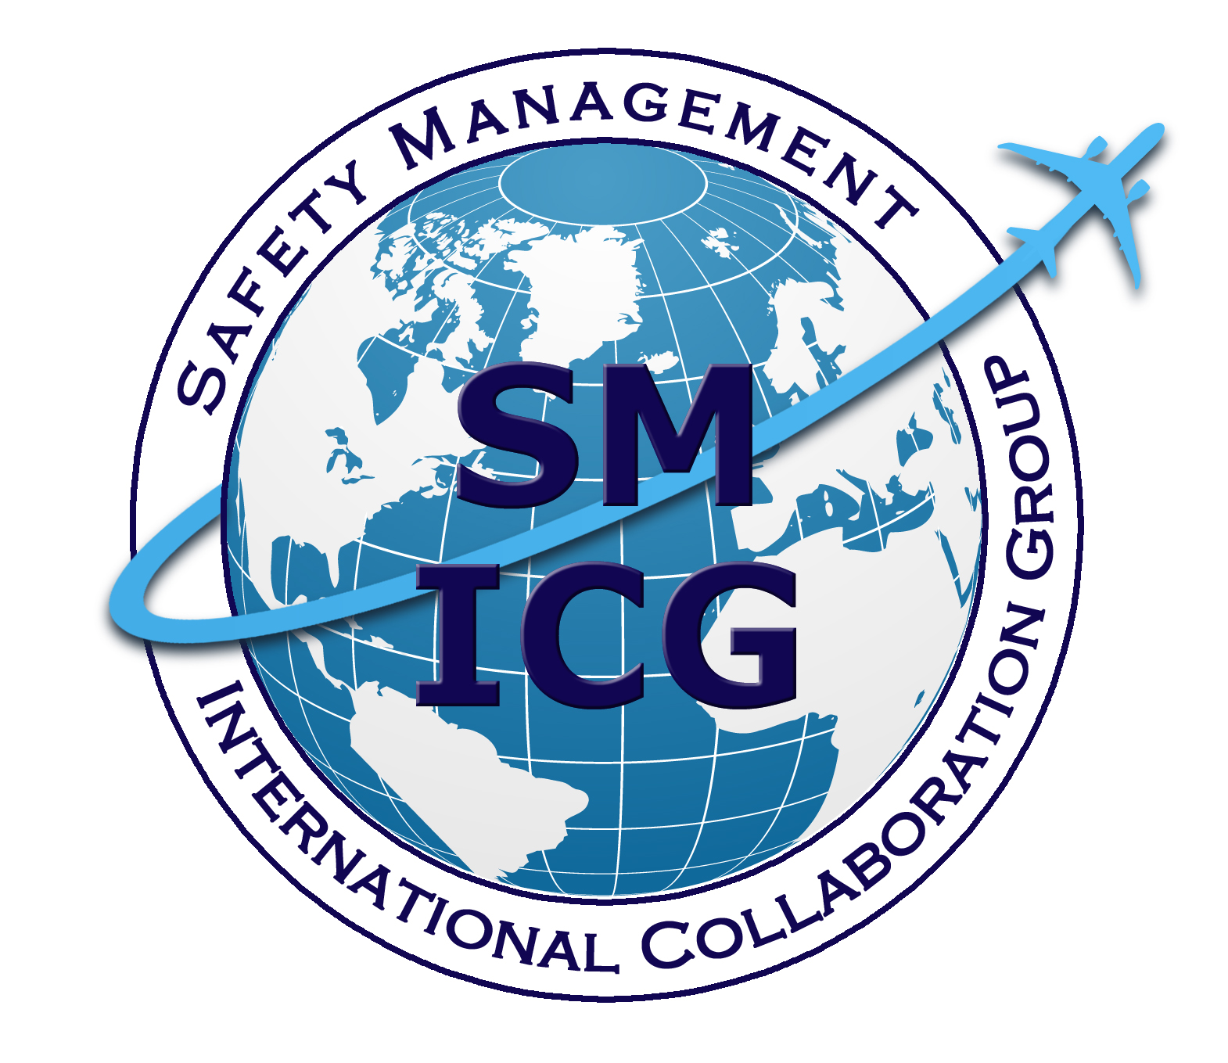
May 2016
SM ICG Findings on SMS Equivalence
This paper was prepared by the Safety Management International Collaboration Group (SM ICG). The purpose of the SM ICG is to promote a common understanding of Safety Management System (SMS)/State Safety Program (SSP) principles and requirements, facilitating their application across the international aviation community. In this document, the term “organization” refers to a product or service provider, operator, business, and company, as well as aviation industry organizations; and the term “authority” refers to the regulator authority, Civil Aviation Authority (CAA), National Aviation Authority (NAA), and any other relevant government agency or entity with oversight responsibility.

The current core membership of the SM ICG includes the Aviation Safety and Security Agency (AESA) of Spain, the National Civil Aviation Agency (ANAC) of Brazil, the Civil Aviation Authority of the Netherlands (CAA NL), the Civil Aviation Authority of New Zealand, the Civil Aviation Authority of Singapore (CAAS), the Civil Aviation Safety Authority (CASA) of Australia, the Direction Générale de l'Aviation Civile (DGAC) in France, the Ente Nazionale per l'Aviazione Civile (ENAC) in Italy, the European Aviation Safety Agency (EASA), the Federal Office of Civil Aviation (FOCA) of Switzerland, the Finnish Transport Safety Agency (Trafi), the Irish Aviation Authority (IAA), Japan Civil Aviation Bureau (JCAB), the United States Federal Aviation Administration (FAA) Aviation Safety Organization, Transport Canada Civil Aviation (TCCA) and the Civil Aviation Authority of United Kingdom (UK CAA). Additionally, the Civil Aviation Department of Hong Kong (CAD HK), the International Civil Aviation Organization (ICAO), and the United Arab Emirates General Civil Aviation Authority (UAE GCAA) are observers to this group.

Members of the SM ICG:
- Collaborate on common SMS/SSP topics of interest
- Share lessons learned
- Encourage the progression of a harmonized SMS/SSP
- Share products with the aviation community
- Collaborate with international organizations such as ICAO and civil aviation authorities that have implemented or are implementing SMS and SSP

For further information regarding the SM ICG please contact:
Regine Hamelijnck Jacqueline Booth Amer M. Younossi
EASA TCCA FAA, Aviation Safety
+49 221 8999 000 (613) 952-7974 (202) 267-5164
regine.hamelijnck@easa.europa.eu jacqueline.booth@tc.gc.ca Amer.M.Younossi@faa.gov

Igor Penna Mike Hutchinson
ANAC CASA
+55 613 3144 826 +03 9518 2774
igor.penna@anac.gov.br Mike.Hutchinson@casa.gov.au

SM ICG products can be found on SKYbrary at: http://bit.ly/SMICG

To obtain an editable version of this document, contact smicg.share@gmail.com.

International Civil Aviation Organization (ICAO) standards require each State to implement a State Safety Program (SSP). SSP standards include mandates for States to require certain aviation organizations to implement Safety Management Systems (SMS). A number of organizations worldwide have expressed concern regarding implementation and acceptance processes for Safety Management Systems (SMSs). This is especially acute for organizations that are subject to certification, approval, or other authorizations of their products and services by multiple authorities.

In many cases, SMSs will be a prerequisite for issuance of an organizational certificate. This is the case for those organizations whose activities are controlled by certification of their operational processes, such as Air Operator Certificate (AOC) holders and Approved Maintenance Organizations (AMOs). State–organization relationships for type certificate holders and production certificate holders, however, are more varied between authorities. For example, some authorities certificate design organizations and some do not. In either case, the product itself is also subject to type design approval or certification.

For authorities, the problem becomes one of ensuring an equivalent level of safety when granting authorizations for other States’ organizations without imposing excessive technical, legal, and administrative burdens on the organizations. For organizations, the problem becomes one of not only being required to go through multiple authorities’ acceptance and auditing processes, it also presents them with the possibility of conflicting requirements, a significant management problem.

While ICAO standards outline requirements for SMS, including a detailed SMS framework, the performance of any organizational system or process in practice depends not only on the regulatory compliance, but the way in which those requirements are implemented. For States to be confident in the equivalence of safety performance of organizations whose SMSs have been accepted by another State, the two states will need to agree on standards, expectations for final implementation, acceptance processes, performance measurement strategies, and processes for continued oversight.

The Safety Management International Collaboration Group (SM ICG), a chartered group of technical representatives of several aviation safety authorities, was asked to analyze the issue of equivalence of SMS and the implications of SMS acceptance among authorities. The group found two major components to this issue.

The first component concerns the nature of mutual or reciprocal recognition of SMS by different authorities. It was recognized that there are existing precedents and current processes for dealing with this part of the issue, including bi-lateral agreements that cover a broad range of aviation organizations, products, services, and activities. These involve a mixture of diplomatic, legal, and technical arrangements between States. Considering the group’s charter and core expertise, it was the consensus of the SM ICG that the latter element should be the sole focus of the group’s analysis. The SM ICG members also felt that existing frameworks for interaction between states were adequate. However, in all cases of bi-lateral actions, an assessment of technical equivalence is necessary.

The second component further breaks down the subject of technical equivalence into five areas. SM ICG members offered that there is more to technical equivalence than simply having a common set of standards. If the primary interest is in the “bottom line” performance of the products, services, or processes of the organizations, whose SMS is being evaluated, additional elements must be evaluated. Having a commonly accepted framework for evaluating SMSs should make these evaluations more structured and efficient. Those elements include:
- Basic Process Requirements. While not sufficient to establish equivalence, use of a common set of basic core requirements is necessary. These have been established in the various ICAO Annexes.
- Implementation Expectations. Each State will prepare specific expectations for processes, programs, methods, and tools related to implementing and demonstrating performance on the part of organizations. This is where the basic requirements are interpreted into operational definitions, documentation and record-keeping requirements, and procedures.
- Acceptance Methodology. The methods that the State uses to evaluate the process design and management capability of the organization may vary between states. This is usually a function of the State’s oversight system (Critical Element of Oversight number 6 – Licensing, Certification and Approval). The combination of specific requirements for implementation and the methodology for acceptance by the State is a large determinant of performance capability. The SM ICG developed an SMS Evaluation Tool that could be used to support this task.
- Performance Measurement. States must measure performance of safety management practices in the SMS. Therefore, the methodology used by each State to measure safety performance of organizations is important in understanding the performance potential and status of organizations certificated or otherwise approved/accepted by the State.
- Continuing Oversight Policies and Methods. In order to assure the performance status of organizations and their SMSs, continuing oversight is essential. This is also part of a State’s oversight responsibility (Critical Element of Oversight number 7 – Surveillance Obligations). Thus, each State must have a good understanding and mutual confidence in the methods used to oversee organizations’ SMSs in order to establish equivalence. This will provide confidence that the organization is maintaining the same performance capability that was established at initial acceptance.

The SM ICG’s existing areas of study encompass most of these five critical elements. Therefore, the group offers to continue current projects and, where necessary, draw linkages to the above areas in order to contribute to mutual understanding of the elements of technical equivalence. Implementation of the products to be developed by SM ICG Project Teams will provide a baseline for establishing technical equivalence of SMS performance.

The SM ICG also recognizes that the issue of equivalence is most acute for design organizations, where differences in certification processes are most significant. The next most potentially problematic area would be in the case of AMOs, where organizational certification is nearly universal but where certification by multiple states’ authorities is common.

